Online Appendix A. Description of analytic samples
(authors’ calculations of means or percentages; estimates are weighted to be nationally representative)

Survey | American Time Use Study (ATUS) | ATUS Well-being Module | American Historical Time Use Study (AHTUS)
Total analytic N | 210,586 | 37,088 | 155,891
N by year | 2003, N = 20,720 | 2010, N = 13,260 | 1965, N = 2,021
 | 2004, N = 13,973 | 2012, N = 12,443 | 1975, N = 4,546
 | 2005, N = 13,038 | 2013, N = 11,385 | 1993, N = 7,471
 | 2006, N = 12,943 |  | 1995, N = 1,189
 | 2007, N = 12,248 |  | 1998, N = 2,337
 | 2008, N = 12,723 |  | 2003, N = 19,484
 | 2009, N = 13,133 |  | 2004, N = 13,165
 | 2010, N = 13,260 |  | 2005, N = 12,257
 | 2011, N = 12,479 |  | 2006, N = 12,056
 | 2012, N = 12,443 |  | 2007, N = 11,478
 | 2013, N = 11,385 |  | 2008, N = 11,956
 | 2014, N = 11,592 |  | 2009, N = 12,451
 | 2015, N = 10,905 |  | 2010, N = 12,524
 | 2016, N = 10,493 |  | 2011, N = 11,853
 | 2017, N = 10,223 |  | 2012, N = 11,850
 | 2018, N = 9,593 |  | 2018, N = 9,253
 | 2019, N = 9,435
Demographic characteristics
Ethnoracial group (ATUS)
White, non-Hispanic | 68 percent | 67 percent | N/A
Black, non-Hispanic | 12 percent | 12 percent | N/A
Hispanic | 15 percent | 15 percent | N/A
Asian, non-Hispanic | 4 percent | 4 percent | N/A
Other race/ethnicity | 2 percent | 2 percent | N/A
Ethnoracial group (AHTUS)
White | N/A | N/A | 81 percent
Black | N/A | N/A | 13 percent
Other | N/A | N/A | 5 percent
Sex
Male | 48 percent | 48 percent | 48 percent
Female | 52 percent | 52 percent | 52 percent
Age | 45 years | 45 years | 47 years
Educational attainment
Less than high school | 17 percent | 17 percent | 11 percent
High school graduate or GED | 29 percent | 29 percent | 28 percent
Some college | 25 percent | 25 percent | 20 percent
College graduate | 18 percent | 19 percent | 30 percent
Any post-graduate education | 10 percent | 10 percent | 12 percent
Employment status (ATUS)
Employed full time | 49 percent | 47 percent | N/A
Employed part time | 14 percent | 14 percent | N/A
Not working – not retired | 22 percent | 25 percent | N/A
Not working – retired | 15 percent | 14 percent | N/A
Employment status (AHTUS)
Employed full time | N/A | N/A | 54 percent
Employed part time | N/A | N/A | 13 percent
Not working | N/A | N/A | 33 percent
Nativity
Native born | 86 percent | 85 percent | N/A
Foreign born | 14 percent | 15 percent | N/A
Martial status
Married | 53 percent | 52 percent | N/A
Widowed, separated, divorced | 17 percent | 17 percent | N/A
Unmarried | 30 percent | 30 percent | N/A
Marital status (AHUS)
Married | N/A | N/A | 55 percent
Unmarried | N/A | N/A | 45 percent
Any coresident children | 40 percent | 40 percent | 44 percent
Urban/rural
Urban | 83 percent | 84 percent | N/A
Rural | 17 percent | 16 percent | N/A
Census region
Northeast | 18 percent | 18 percent | 17 percent
Midwest | 24 percent | 24 percent | 25 percent
South | 36 percent | 36 percent | 36 percent
West | 22 percent | 22 percent | 22 percent
Month of time diary
January | 9 percent | 9 percent | 10 percent
February | 7 percent | 7 percent | 8 percent
March | 8 percent | 8 percent | 9 percent
April | 8 percent | 9 percent | 8 percent
May | 8 percent | 8 percent | 8 percent
June | 8 percent | 8 percent | 8 percent
July | 8 percent | 9 percent | 8 percent
August | 9 percent | 8 percent | 8 percent
September | 8 percent | 8 percent | 8 percent
October | 9 percent | 8 percent | 8 percent
November | 8 percent | 9 percent | 8 percent
December | 9 percent | 9 percent | 8 percent
Day of week of time diary
Monday | 14 percent | 14 percent | 14 percent
Tuesday | 14 percent | 14 percent | 14 percent
Wednesday | 14 percent | 14 percent | 14 percent
Thursday | 14 percent | 14 percent | 14 percent
Friday | 14 percent | 14 percent | 14 percent
Saturday | 14 percent | 14 percent | 14 percent
Sunday | 14 percent | 14 percent | 14 percent
Note: Percentages may not sum to 100 due to rounding.
Online Appendix B. Portion of neutral downtime spent watching television/videos
(unadjusted and adjusted predicted values from the
American Time Use Survey, 2003-2019)

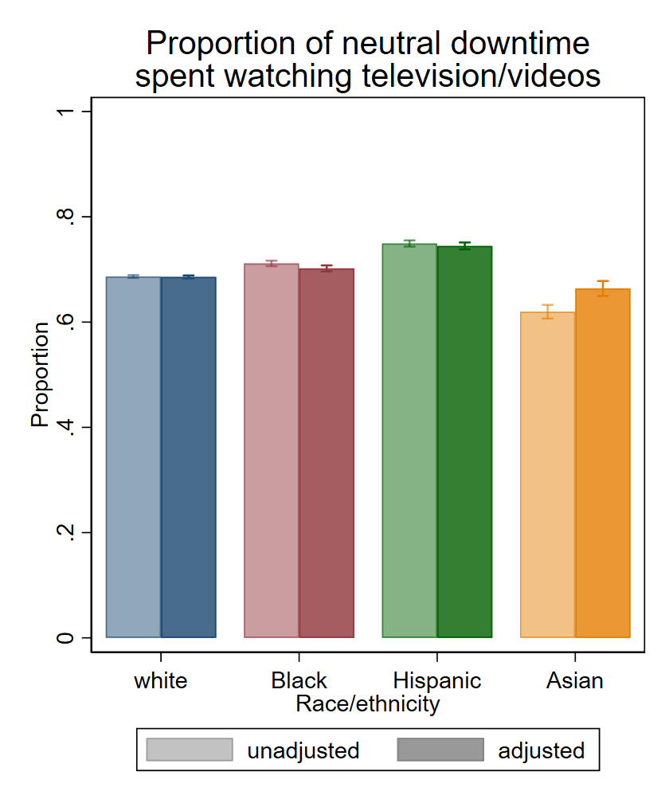

Online Appendix C. Ethnoracial differences in ratio of time spent in daily activities to white people’s time in activity
(unadjusted and adjusted predicted values and 95% confidence intervals from the
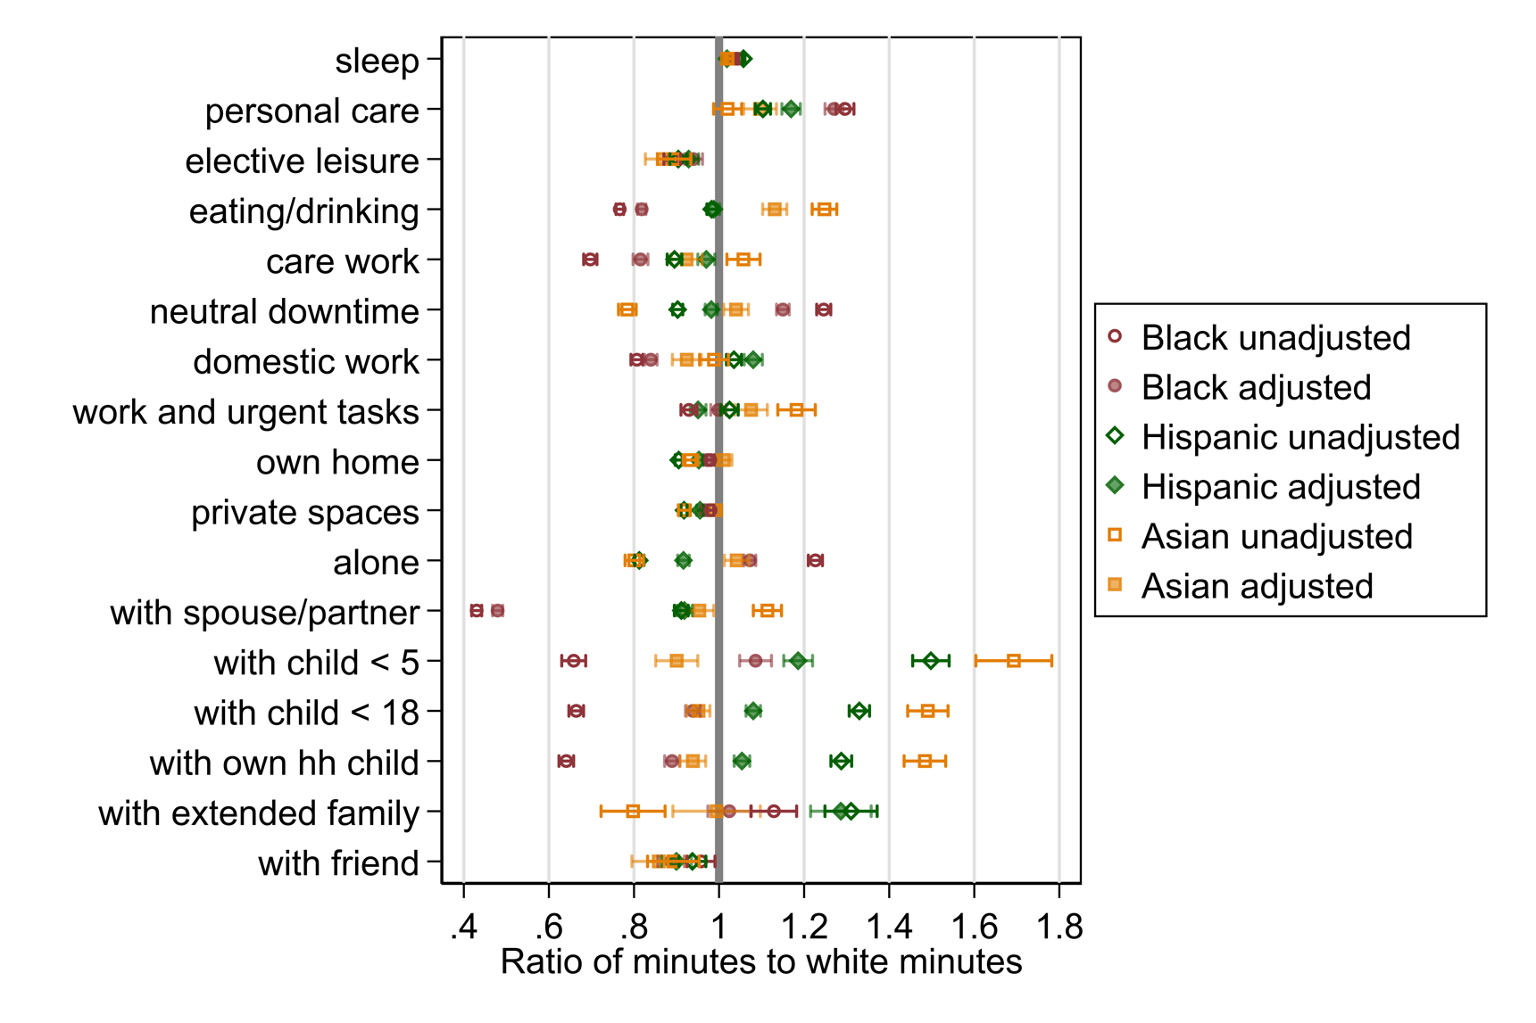
American Time Use Survey 2003-2019)
With whom

Where

Activity

Online Appendix D. Ethnoracial similarity in daily unpleasantness of exemplar activities
(estimates and 95% confidence intervals from the
American Time Use Survey Well-Being Model, 2010, 2012, 2013) 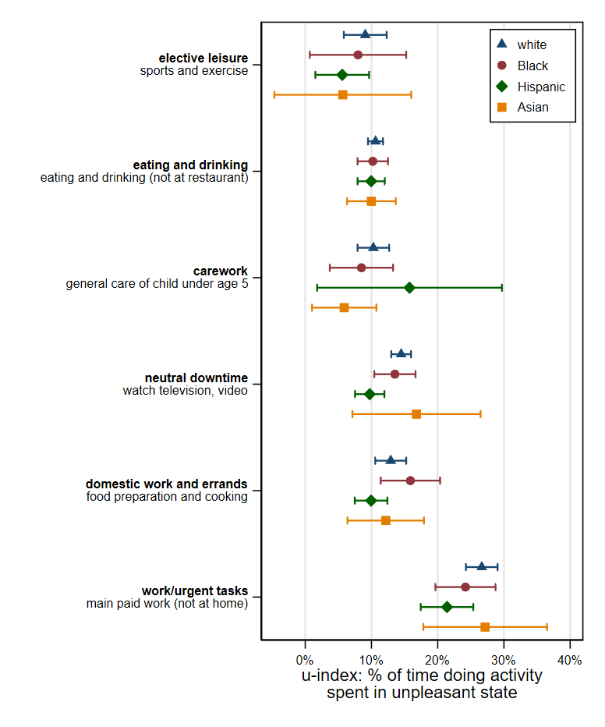

Online Appendix E. Daily unpleasantness by sex
(unadjusted and adjusted predicted values and 95% confidence intervals from the
American Time Use Survey, 2003-2019)

Authors’ calculations. Adjusted estimates are adjusted for age, age squared, educational attainment, employment status, nativity, marital status, any coresident children under age 18, urban/rural residence, Census region, ten-year group, month, and day of week.
Authors’ calculations of marginal effects from count models of time spent on daily activities: negative binomial models of number of minutes spent on sleep, personal care, elective leisure, eating and drinking, neutral downtime, domestic work and errands, at home, in private spaces, alone, with extended family, and with friends and zero-inflated negative binomial models to model the number of minutes spent on work and urgent tasks, with spouse/partner, with children under age 5, with children under age 18, and with a coresident child. Estimates are adjusted for sex, age, age squared, educational attainment, employment status, nativity, marital status, any coresident children under age 18, urban/rural residence, Census region, ten-year group, month, and day of week.
Authors’ calculations of average u-index values by ethnoracial group across 160 race-specific u-index calculations (using 160 replicate weights). Confidence intervals represent the uncertainty in the u-index estimate from using 160 different replicate weights.
Authors’ calculations of predicted level of daily unpleasantness from ordinal least squares regressions of the proportion of the waking day spent in an unpleasant state. Models comparing include an interaction term for sex * ethnoracial group. Estimates are adjusted for age, age squared, educational attainment, employment status, nativity, marital status, any coresident children under age 18, urban/rural residence, Census region, ten-year group, month, and day of week.

