Appendix

Table A.1. Descriptive Statistics
 |  |  | Wildfire (+/–1 year) | Wildfire (+/–1 year) >5,000 Acres  Maternal Education Category
Variable |  | All | >5,000 Acres | < High School | High School | Some College | Bachelor’s +
Infant Health
 | Birth weight (grams) | 3,318.01 | 3,324.74 | 3,295.33 | 3,305.92 | 3,335.38 | 3,370.05
 | Low birth weight | 0.06 | 0.06 | 0.06 | 0.06 | 0.05 | 0.04
 | Gestational length (weeks) | 38.79 | 38.81 | 38.76 | 38.78 | 38.81 | 38.91
 | Preterm birth | 0.10 | 0.10 | 0.11 | 0.10 | 0.09 | 0.07
 | Intrauterine growth restriction | 0.11 | 0.10 | 0.11 | 0.11 | 0.10 | 0.09
 | Death (per thousand) | 1.423 | 5.957 | 4.047 | 4.203 | 3.593 | 2.934
Wildfire exposure timing
 | First trimester | 0.02 | 0.12 | 0.12 | 0.12 | 0.12 | 0.12
 | Second trimester | 0.02 | 0.08 | 0.08 | 0.08 | 0.08 | 0.08
 | Third trimester | 0.03 | 0.11 | 0.11 | 0.11 | 0.11 | 0.11
Maternal characteristics
 | < High school | 0.19 | 0.24 | 1 | 0 | 0 | 0
 | High school | 0.29 | 0.29 | 0 | 1 | 0 | 0
 | Some college | 0.25 | 0.25 | 0 | 0 | 1 | 0
 | Bachelor’s + | 0.27 | 0.22 | 0 | 0 | 0 | 1
 | White | 0.56 | 0.40 | 0.15 | 0.37 | 0.49 | 0.61
 | Black | 0.14 | 0.08 | 0.06 | 0.11 | 0.10 | 0.05
 | American Indian | 0.01 | 0.02 | 0.02 | 0.02 | 0.02 | 0.01
 | Asian | 0.05 | 0.07 | 0.02 | 0.04 | 0.06 | 0.16
 | Latina | 0.23 | 0.43 | 0.74 | 0.45 | 0.33 | 0.18
 | Age | 27.70 | 27.59 | 25.22 | 26.07 | 28.04 | 31.68
Other birth characteristics
 | Male infant | 0.51 | 0.51 | 0.51 | 0.51 | 0.51 | 0.52
 | Parents married | 0.63 | 0.62 | 0.42 | 0.52 | 0.67 | 0.91
 | Birth year | 2007.53 | 2006.66 | 2005.15 | 2006.34 | 2007.69 | 2007.61
 | Birth month | 6.57 | 6.59 | 6.58 | 6.61 | 6.59 | 6.56
County characteristics
 | Maximum AQI | 160.92 | 194.60 | 203.07 | 195.64 | 189.67 | 189.32
 | Median AQI | 47.61 | 62.24 | 67.12 | 62.05 | 59.68 | 59.91
 | Acres burned | 33,502.03 | 556,18.28 | 59,336.11 | 54,543.98 | 53,799.88 | 54,958.38
 | Unemployment rate | 5.79 | 6.51 | 6.78 | 6.56 | 6.49 | 6.17
 | Poverty rate | 13.82 | 15.13 | 15.83 | 15.31 | 14.99 | 14.28
 | Median income $ | 63,373.43 | 62,141.81 | 61,606.43 | 61,003.70 | 61,737.86 | 64,683.96
N births |  | 9,456,694 | 1,389,357 | 338,452 | 401,320 | 343,981 | 305,604
Source: Authors’ tabulation using CDC (2020); EPA (2021); MTBS (2022).
Note: NVSS birth data 1995–2020; EPA AQI data 1995–2020; MTBS data 1995–2020. Annual random 10 percent sample of singleton births with health and maternal information. Wildfire columns are limited to births in counties with a wildfire within one year that burned more than five thousand acres.

Table A.2. Estimated Relationship Between Wildfire Severity and Air Quality

Panel A. Maximum AQI
 | (1) | (2) | (3) | (4)
Variables | Maximum AQI (log)
Acres burned (log) | 0.027** | 0.030**
 | (0.007) | (0.007)
% acres burned |  |  | 0.027** | 0.030**
 |  |  | (0.007) | (0.007)
Max AQI year t–1 |  | 0.349** |  | 0.349**
 |  | (0.044) |  | (0.044)
Wildfire start month | 0.005 | 0.003 | 0.005 | 0.003
 | (0.004) | (0.004) | (0.004) | (0.004)
Constant | 2.118 | 1.589 | 2.375 | 1.877
 | (1.709) | (1.599) | (1.703) | (1.590)
Observations | 2,961 | 2,883 | 2,961 | 2,883
R² | 0.698 | 0.742 | 0.698 | 0.742
County and year fixed effects | Y | Y | Y | Y

Panel B. 90th percentile AQI
 | (1) | (2) | (3) | (4)
Variables | 90th Percentile AQI (log)
Acres burned (log) | 0.009+ | 0.016**
 | (0.005) | (0.004)
% acres burned (log) |  |  | 0.009+ | 0.016**
 |  |  | (0.005) | (0.004)
90th percentile AQI year t–1 |  | 0.591** |  | 0.591**
 |  | (0.035) |  | (0.035)
Wildfire start month | 0.004 | 0.002 | 0.004 | 0.002
 | (0.003) | (0.002) | (0.003) | (0.002)
Constant | 2.522+ | 0.735 | 2.604* | 0.887
 | (1.286) | (0.935) | (1.290) | (0.938)
Observations | 2,961 | 2,883 | 2,961 | 2,883
R² | 0.773 | 0.864 | 0.773 | 0.864
County and year fixed effects | Y | Y | Y | Y

Panel C. Unhealthy Days
 | (1) | (2) | (3) | (4)
Variables | Unhealthy Days (log)
Acres burned (log) | 0.094** | 0.084*
 | (0.029) | (0.034)
% acres burned (log) |  |  | 0.094** | 0.084*
 |  |  | (0.029) | (0.034)
Unhealthy days year t–1 |  | 0.230** |  | 0.230**
 |  | (0.086) |  | (0.086)
Wildfire start month | 0.009 | 0.004 | 0.009 | 0.004
 | (0.018) | (0.018) | (0.018) | (0.018)
Constant | –2.404 | –0.381 | –1.499 | 0.434
 | (7.468) | (7.585) | (7.505) | (7.621)
Observations | 1,080 | 703 | 1,080 | 703
R² | 0.748 | 0.787 | 0.748 | 0.787
County and year fixed effects | Y | Y | Y | Y

Panel D. Descriptive Statistics: County-Years with Wildfires
Variable | Mean | SD | Minimum | Maximum
Maximum AQI | 182.96 | 558.03 | 0.00 | 13276.00
90th percentile AQI | 69.78 | 34.88 | 0.00 | 509.00
Unhealthy days | 2.35 | 10.98 | 0.00 | 183.00
Acres burned | 22408.61 | 60857.76 | 500.00 | 657299.00
% acres burned | 1.98 | 6.99 | 0.00 | 100.00
Fire year | 2007.74 | 6.98 | 1995.00 | 2020.00
N county-years | 6,285

Source: Authors’ tabulation using EPA (2021); MTBS (2022).
Note: MTBS data 1995–2020; EPA AQI data 1995–2020. Sample is limited to county-years with a wildfire and AQI data. The most severe wildfire is selected for county-years with more than one wildfire. AQI is the air quality index used by the EPA and ranges from 0 to 500. Higher values indicate higher air pollution and values above 500 are possible but beyond the index scale (EPA 2021; National Interagency Fire Center 2013).

Table A.3. Prenatal Wildfire Exposure by Maternal Education
 | < High School | High School | Some College | Bachelor’s+
First Trimester | 0.03 | 0.02 | 0.02 | 0.02
Second trimester | 0.02 | 0.02 | 0.02 | 0.02
Third trimester | 0.03 | 0.03 | 0.03 | 0.02
Number of wildfires | 18.89 | 17.88 | 17.62 | 17.42
Number of wildfires - class G | 19.00 | 17.82 | 17.31 | 17.54
Counties with wildfire:
% acres burned | 2.07 | 1.97 | 2.04 | 2.14
Acres burned | 38158.66 | 32050.39 | 31611.13 | 32852.46
N births | 1782842 | 2699603 | 2386830 | 2587419
Source: Authors’ tabulation using EPA (2021); MTBS (2022).
Note: NVSS birth data 1995–2020; MTBS data 1995–2020. Annual random 10% sample of singleton births with health and maternal information. The most severe wildfire is selected for county-years with more than one wildfire. Class G wildfires burned more than five thousand acres.

Table A.4. County-Level Economic Correlation with Wildfire Occurrence and Severity
County-level correlation | % Poverty | Median Income
Number of wildfires | 0.037 | –0.010
Number of wildfires - class G | 0.004 | 0.018
% acres burned | 0.001 | –0.005
Acres burned | 0.005 | –0.002
N county-years | 87955 | 87950
Source: Authors’ tabulation using MTBS (2022); U.S. Census Bureau (2021).
Note: MTBS data 1995–2020; SAIPE data 1995–2020. Sample is limited to county-years with SAIPE economic data. The most severe wildfire is selected for county-years with more than one wildfire. Class G wildfires burned more than five thousand acres.

Table A.5. Estimated Relationship Between Wildfire Exposure and Likelihood of Preterm Birth by Maternal Education
 |  |  | < High School |  | High School |  | Some College |  | Bachelor’s +
Limited to live births
 |  | Trimester 1 | –0.0033** | (0.0012) | –0.0001 | (0.0016) | –0.0009 | (0.0014) | –0.0023 | (0.0017)
 |  | Trimester 2 | 0.0049* | (0.0022) | –0.0007 | (0.0027) | –0.0004 | (0.0020) | –0.0007 | (0.0021)
 |  | Trimester 3 | –0.0003 | (0.0013) | 0.0021 | (0.0015) | 0.0032* | (0.0014) | 0.0029 | (0.0016)
 |  | N | 170,716 |  | 197,373 |  | 163,812 |  | 149,114
Including fetal deaths
 |  | Trimester 1 | –0.0034** | (0.0012) | –0.0001 | (0.0016) | –0.0010 | (0.0014) | –0.0024 | (0.0017)
 |  | Trimester 2 | 0.0050* | (0.0022) | –0.0005 | (0.0027) | –0.0003 | (0.0020) | –0.0006 | (0.0021)
 |  | Trimester 3 | –0.0005 | (0.0013) | 0.0018 | (0.0015) | 0.0030* | (0.0014) | 0.0028 | (0.0016)
 |  | N | 173,388 |  | 201,030 |  | 166,154 |  | 150,835
Controlling for seasonality
 |  | Trimester 1 | –0.0034** | (0.0012) | –0.0001 | (0.0016) | –0.0010 | (0.0014) | –0.0024 | (0.0017)
 |  | Trimester 2 | 0.0050* | (0.0022) | –0.0005 | (0.0027) | –0.0003 | (0.0020) | –0.0006 | (0.0021)
 |  | Trimester 3 | –0.0005 | (0.0013) | 0.0018 | (0.0015) | 0.0030* | (0.0014) | 0.0028 | (0.0016)
 |  | N | 173,388 |  | 201,030 |  | 166,154 |  | 150,835
Controlling for air quality
 |  | Trimester 1 | –0.0031* | (0.0013) | –0.0000 | (0.0016) | –0.0011 | (0.0015) | –0.0027 | (0.0018)
 |  | Trimester 2 | 0.0054* | (0.0022) | 0.0001 | (0.0027) | –0.0005 | (0.0020) | –0.0005 | (0.0021)
 |  | Trimester 3 | –0.0006 | (0.0013) | 0.0023 | (0.0015) | 0.0034* | (0.0015) | 0.0033* | (0.0016)
 |  | N | 165,436 |  | 187,467 |  | 155,447 |  | 144,179
Source: Authors’ tabulation using CDC (2020); EPA (2021); MTBS (2022).
Note: NVSS birth and fetal death data 1995–2020; EPA AQI data 1995–2020; MTBS data 1995–2020. Sample includes births and fetal deaths conceived twenty-one months before to twelve months after the largest county Class G wildfire within one year, with AQI data in models controlling for air quality, and excluding years without maternal education in fetal death data (2007–2013). Models are fit separately by maternal education level and all models control for maternal age, parental marital status, infant sex, estimated conception date (month, year), and fixed effects for month of birth, year of birth, and county of maternal residence. Robust standard errors adjusted for county clustering in parentheses. Shaded cells indicate significant difference from models limited to mothers with < high school, p < .05; $z=({β_{L}-β_{H})}/{\sqrt{{SE}_{L}^{2}+{SE}_{H}^{2}}}$ (Clogg et al. 1995).
+ p < .1; * p < .05; ** p < .01

Figure A.1. Distribution of Wildfire Severity by Month and Year of Start Date
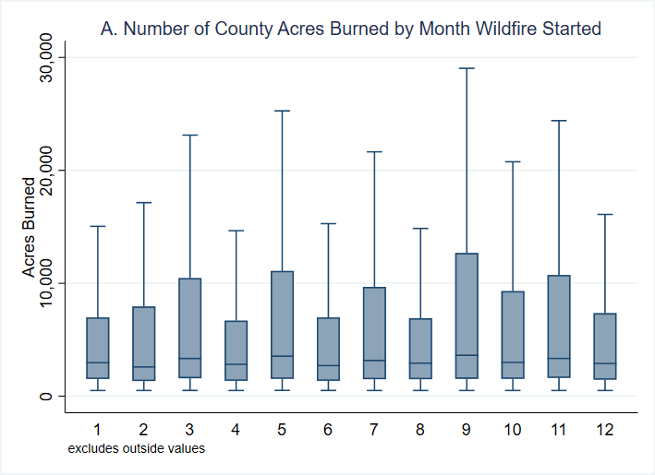

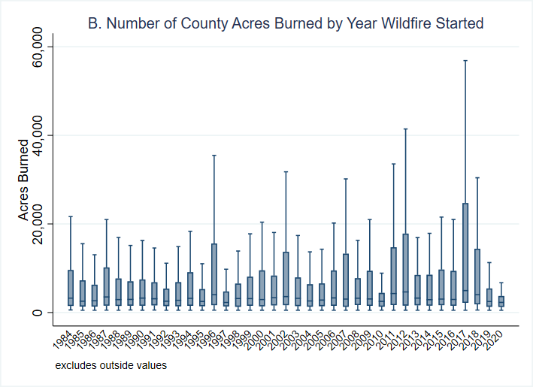

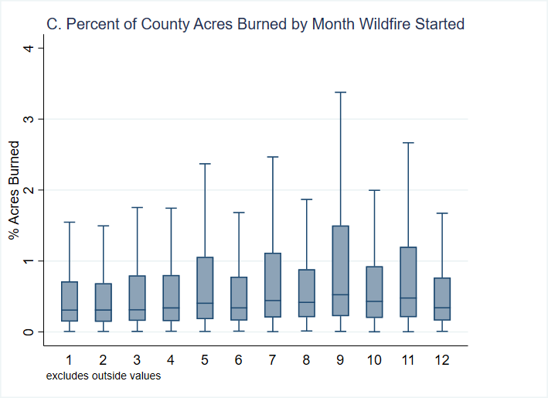

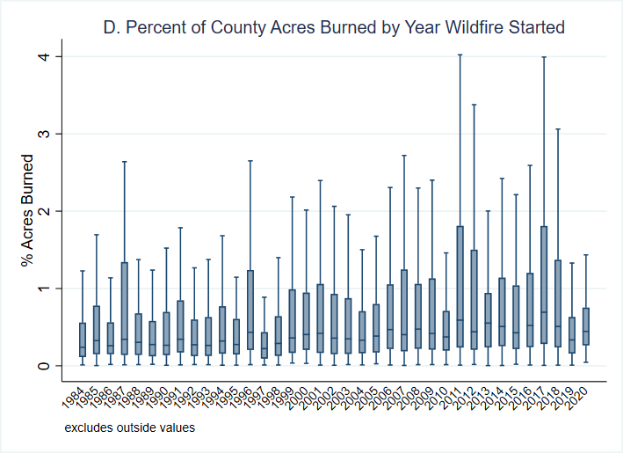

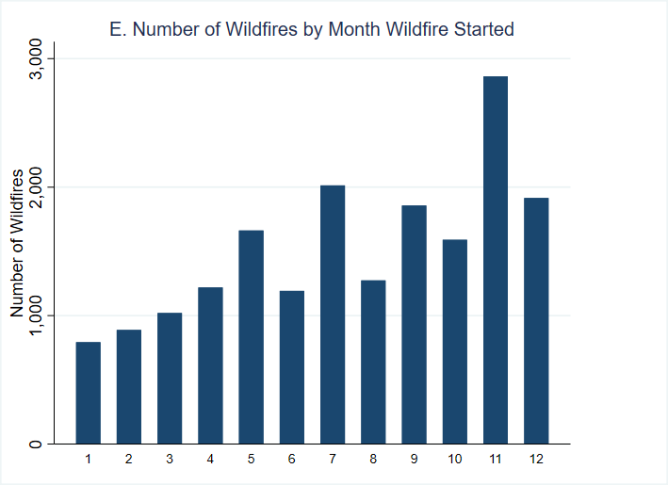

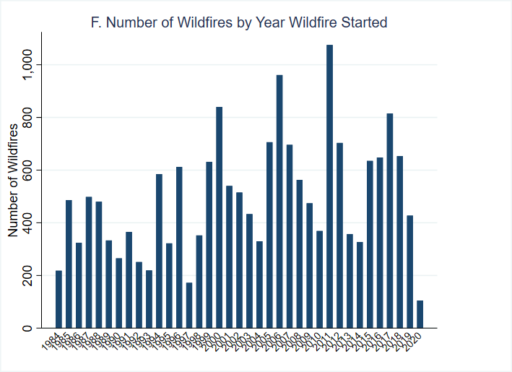
Source: Authors’ tabulation using MTBS (2022).
Note: MTBS data 1984–2020. Panels A–D are limited to county-years with a wildfire and include the most severe wildfire for county-years with more than one wildfire. Panels E and F show the total number of wildfires by year and month of start date.

Figure A.2. Wildfire Perimeter Map, 1995–2020
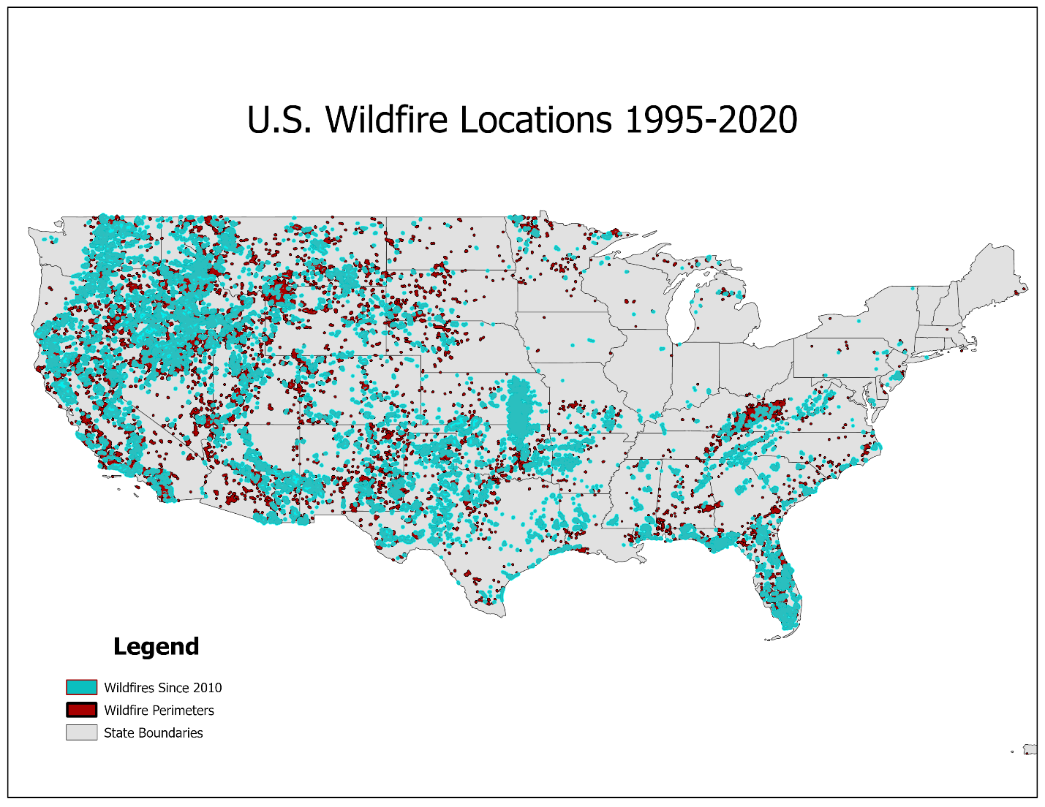
Source: Authors’ tabulation using MTBS (2022).
Note: ArcGIS analyses of MTBS data 1995–2020.

Figure A.3. Predicted Effect of Wildfire Exposure on Likelihood of Preterm Birth
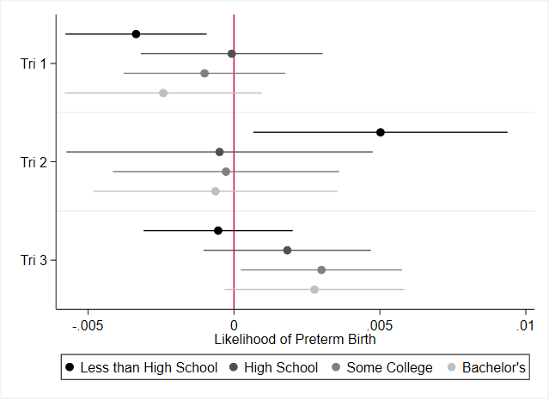
Source: Authors’ tabulation.
Note: Figures show coefficients from table A.5. Error bars indicate 95 percent confidence intervals.

