Harris Online Appendix
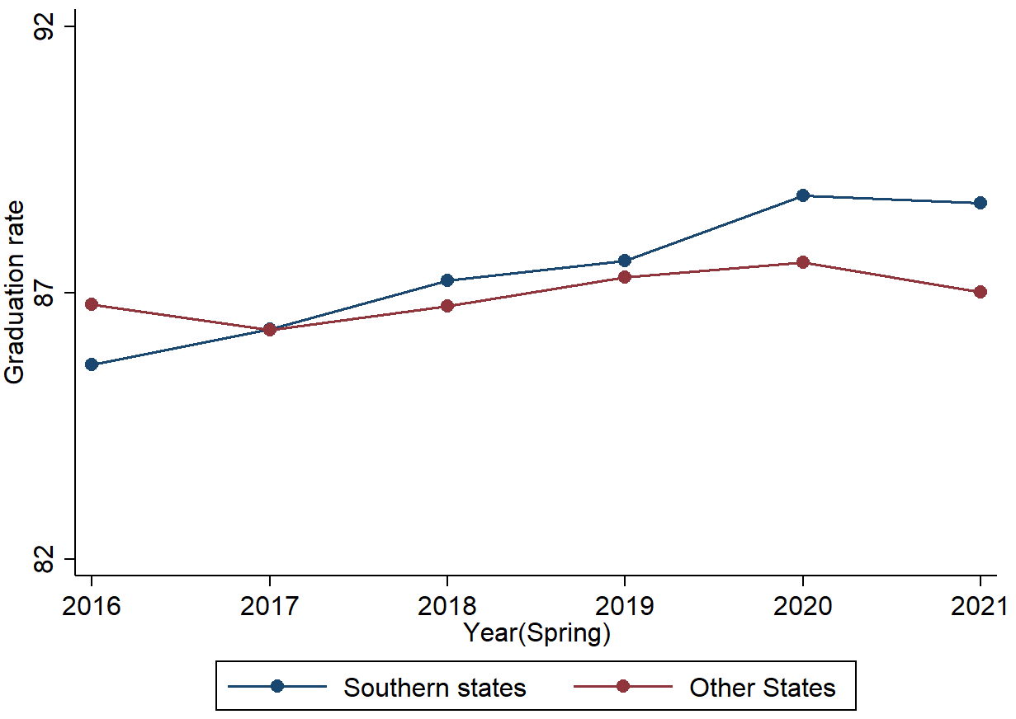
Figure A.1. Trends in High School Graduation for Southern Versus Other States

Source: Authors’ tabulation.
Note: weighted by cohort size, N (district) = 648 for southern states, and N (district) = 4,193 for other states. Southern states in our sample are AL, AR, DE, FL, KY, MD, SC, TN, TX, VA; non-Southern states are AK, AZ, CA, CO, CT, IA, ID, IN, MA, ME, MN, MO, NE, NH, NV, NY, OH, OR, PA, RI, SD, WA, and WY.

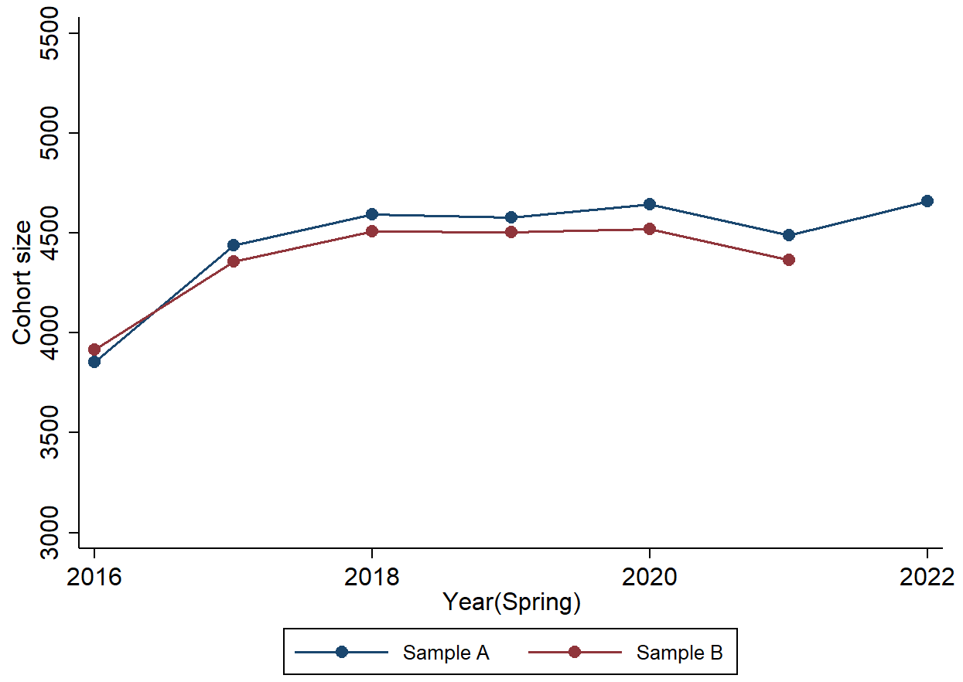
Figure A.2. Trends in High School Cohort Size

Source: Authors’ tabulation.
Note: Sample A includes districts with nonmissing graduation rates of 2016–22, weighted by cohort size, N (district) = 3,163. Sample B includes districts with nonmissing graduation rates of 2016–21, weighted by cohort size, N (district) = 4,841.

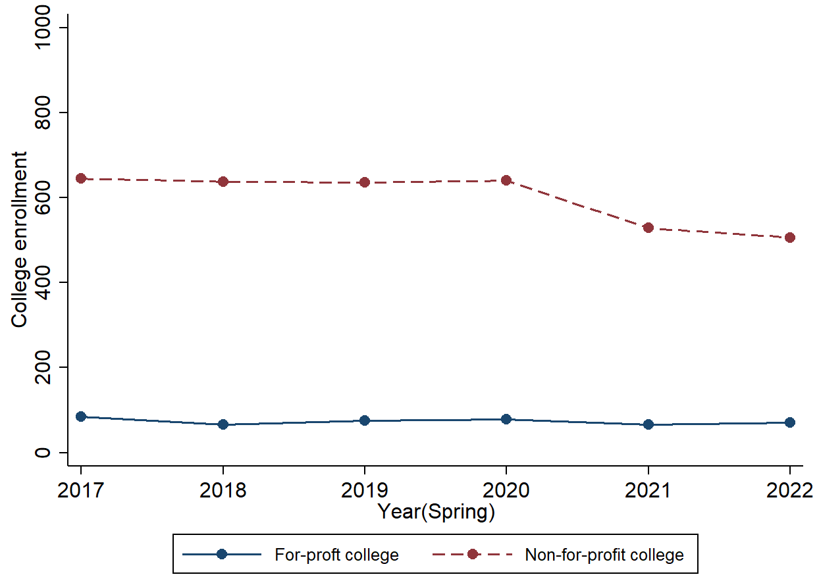
Figure A.3. Trends in Two-Year College Entry, For-Profit Versus Nonprofit

Source: Authors’ tabulation.

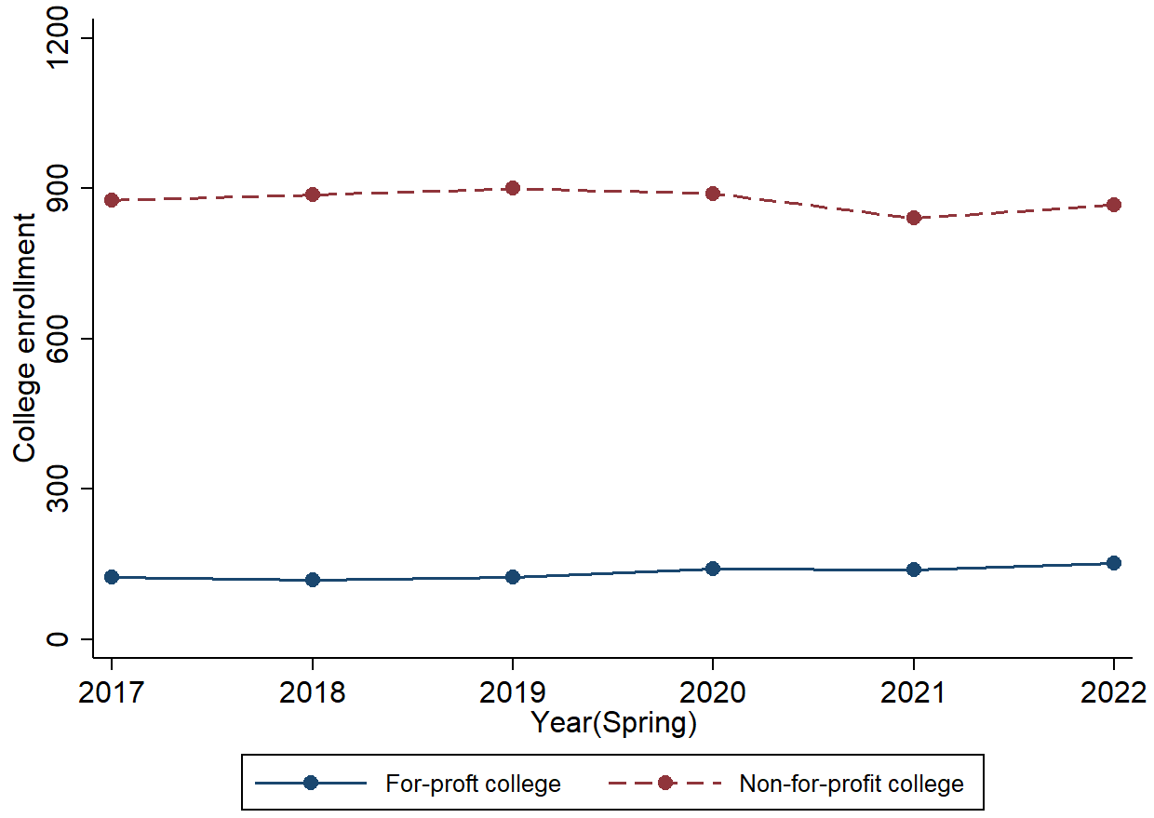
Figure A.4. Trends in Four-Year College Enrollment, For-Profit versus Nonprofit

Source: Authors’ tabulation.

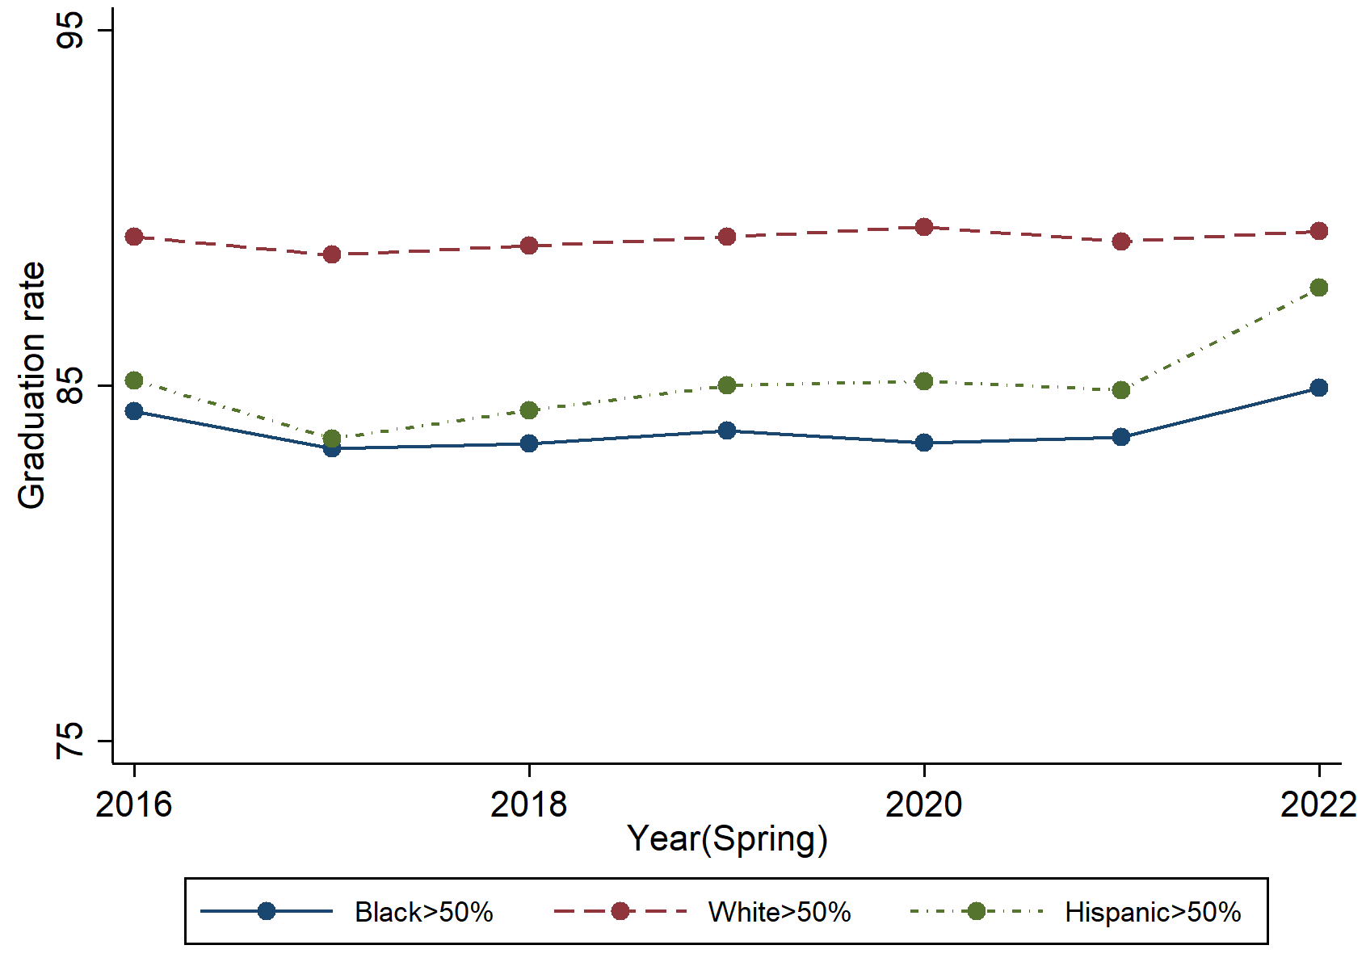
Figure A.5. Trends in High School Graduation by Race

Source: Authors’ tabulation.
Note: The number of districts with Black less than 50 percent is 179, White less than 50 percent is 2,455, and Hispanic less than 5 percent is 334.

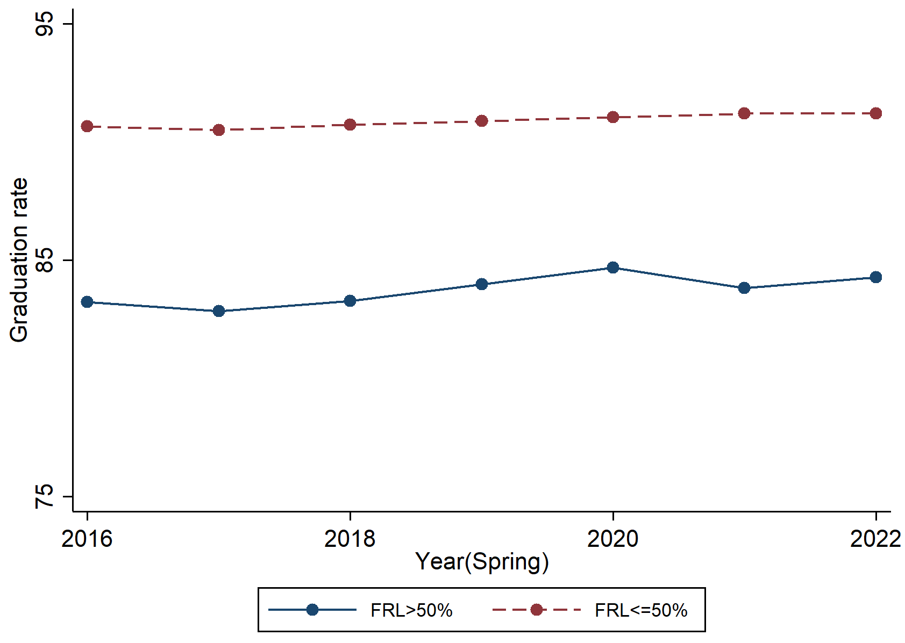
Figure A.6. Trend in High School Graduation Rates by Poverty Level

Source: Authors’ tabulation.
Note: The number of districts for FRL>50% is 1,464, and for FRL<=50% is 1,631.

Table A.1. Samples of States in High School Analyses
State | 2016–21 | 2022 | Cohort size
Alaska | Yes | Yes | Yes
Alabama | Yes | Yes | Yes
Arkansas | Yes | Yes | Yes
Arizona | Yes |  | Yes
California | Yes | Yes | Yes
Colorado | Yes | Yes | Yes
Connecticut | Yes |  | Yes
District Of Columbia
Delaware | Yes |  | Yes
Florida | Yes |  | Yes
Georgia | Yes | Yes
Hawaii
Iowa | Yes | Yes | Yes
Idaho | Yes |  | Yes
Illinois | Yes
Indiana | Yes | Yes | Yes
Kansas | Yes | Yes
Kentucky | Yes |  | Yes
Louisiana | Yes
Massachusetts | Yes |  | Yes
Maryland | Yes | Yes | Yes
Maine | Yes | Yes | Yes
Michigan
Minnesota | Yes |  | Yes
Missouri | Yes | Yes | Yes
Mississippi | Yes | Yes
Montana
North Carolina | Yes
North Dakota | Yes
Nebraska | Yes | Yes | Yes
New Hampshire | Yes |  | Yes
New Jersey | Yes
New Mexico | Yes
Nevada | Yes | Yes | Yes
New York | Yes | Yes | Yes
Ohio | Yes | Yes | Yes
Oklahoma
Oregon | Yes | Yes | Yes
Pennsylvania | Yes |  | Yes
Rhode Island | Yes |  | Yes
South Carolina | Yes | Yes | Yes
South Dakota | Yes | Yes | Yes
Tennessee | Yes | Yes | Yes
Texas | Yes |  | Yes
Utah
Virginia | Yes | Yes | Yes
Vermont
Washington | Yes | Yes | Yes
Wisconsin | Yes |  | Yes
West Virginia | Yes
Wyoming | Yes | Yes | Yes
Total | 44 | 24 | 34
Source: Authors’ tabulation.

Table A.2. Comparing 2022 High School Samples of States on Covariates
Covariates | Sample A  (Twenty-Four States) |  | Sample B  (Forty-Four States) |  | All States
 | Mean | SD | Mean | SD | Mean | SD
In-person | 0.36 | 0.39 | 0.39 | 0.39 | 0.39 | 0.39
Remote | 0.17 | 0.25 | 0.16 | 0.24 | 0.15 | 0.23
LFP | 48.22 | 5.20 | 47.79 | 5.64 | 47.88 | 5.58
StdRelax | 1.79 | 1.01 | 1.78 | 0.91 | 2.01 | 0.93
COVID cases | 89.51 | 26.49 | 91.64 | 24.12 | 90.64 | 23.86
Black | 0.08 | 0.16 | 0.09 | 0.15 | 0.09 | 0.17
Hispanic | 0.19 | 0.22 | 0.21 | 0.24 | 0.17 | 0.22
White | 0.64 | 0.28 | 0.62 | 0.28 | 0.66 | 0.28
Source: Authors’ tabulation.
Note: Sample A includes states that have nonmissing graduation rates for 2016–22, and Sample B includes states that have nonmissing graduation rates for 2016-2021. See table A.1 for the complete list of states.

Table A.3. Regression Results Dropping District-Specific Linear Trends
 | (1) | (2) | (3)
In-Person | 0.487*** | 0.660*** | 0.558
 | [0.183] | [0.185] | [1.099]
Remote | 0.445 | -0.017 | 1.879
 | [0.371] | [0.414] | [1.679]
LFP |  | 0.039 | 0.041
 |  | [0.044] | [0.044]
StdRelax |  | -0.124 | -0.125
 |  | [0.093] | [0.093]
StdRelax* GradExam |  | 0.139** | 0.137**
 |  | [0.065] | [0.065]
COVID cases |  | -0.021*** | -0.018**
 |  | [0.004] | [0.008]
In-person* COVID cases |  |  | 0.001
 |  |  | [0.012]
Remote* COVID cases |  |  | -0.022
 |  |  | [0.018]
Total R² | 0.810 | 0.810 | 0.810
Observations | 34,245 | 34,245 | 34,245
District FE, Year FE | Y | Y | Y
Source: Authors’ tabulations.
Note: Linear regression of high school graduation rate (0 to 100) on learning mode and other covariates Learning mode has three categories: in-person, hybrid, and remote, with hybrid as the reference group. The sample period is school years 2015–16 to 2020–21, excluding 2019–20. Covid Case was defined as cases per 1,000 population. Standard errors in parenthesis are clustered at the district level.
* p < .1; ** p < .05; *** p < .01

