Online Appendix

|  |  |  |  |  |  |  |  |
| --- | --- | --- | --- | --- | --- | --- | --- |
| Table A.1. Demography and Economy in 1930 U.S. Census | | | | | | | |
|  | United States | Ohio | Difference  (2)-(1) | Ohio  Rank | North Carolina | Difference  (4)-(1) | North Carolina  Rank |
|  | (1) | (2) | (3) | (4) | (5) | (6) | (7) |
| Age | 28.8 | 30.2 | 1.34*** | 15 | 24.36 | -4.476*** | 48 |
| Male | 0.506 | 0.505 | -0.000 | 28 | 0.497 | -0.009*** | 43 |
| Black | 0.097 | 0.047 | -0.050*** | 20 | 0.290 | 0.193*** | 7 |
| Foreign born | 0.121 | 0.101 | -0.020*** | 24 | 0.005 | -0.116*** | 49 |
| Ever married | 0.697 | 0.717 | 0.020*** | 11 | 0.680 | -0.017*** | 38 |
| Literacy | 0.955 | 0.977 | 0.022*** | 17 | 0.890 | -0.064*** | 44 |
| Urban residence | 0.562 | 0.678 | 0.117*** | 11 | 0.255 | -0.306*** | 43 |
| Farm residence | 0.248 | 0.152 | -0.096*** | 38 | 0.506 | 0.258*** | 7 |
| Farmer | 0.130 | 0.081 | -0.049*** | 38 | 0.243 | 0.114*** | 12 |
| Agricultural employment | 0.222 | 0.127 | -0.095*** | 40 | 0.434 | 0.211*** | 8 |
| Manufacturing employment | 0.216 | 0.308 | 0.092*** | 7 | 0.214 | -0.002*** | 18 |
| *Source*: Authors’ tabulation using the 1930 Census (Ruggles et al. 2021).  *Note*: Column 1 reports the mean demographic and economic characteristics for the full U.S. population; column 2 and 5 reports the mean characteristics for all people enumerated in Ohio and North Carolina in the 1930 Census, respectively. We calculate mean age, share male, share Black, share foreign born, share literate, share living in urban areas, and share living on farms for the full population. We calculate the share ever married for people older than fifteen. We calculate the share of farmers, share of agricultural employment, and share of manufacturing employment for people older than fifteen who had an occupation. Column (3) and (6) report the mean difference of characteristics between the population residing in the two states and the total U.S. population. Column (4) and (7) report the ranks for Ohio and North Carolina among all forty-nine continental U.S. states (from highest to lowest) in terms of each characteristic.  Marks indicate the statistical significance at which the hypothesis testing for mean equality was rejected.  * *p* < .10; ** *p* < .05; *** *p* < .001 | | | | | | | |

|  |  |  |  |  |  |  |
| --- | --- | --- | --- | --- | --- | --- |
| Table A.2. Correlates of Great Depression Severity and Recovery, Measured as Growth of Retail Sales | | | | | | |
|  | United States | | Ohio Counties | | North Carolina Counties | |
|  | 1929–1933 | 1933–1939 | 1929–1933 | 1933–1939 | 1929–1933 | 1933–1939 |
|  | (1) | (2) | (3) | (4) | (5) | (6) |
| Growth rate in population 1920 to 1930 | -0.036* | 0.084*** | 0.113 | -0.122 | 0.050 | -0.175 |
| (0.021) | (0.020) | (0.141) | (0.154) | (0.195) | (0.183) |
| Manufacturing employees 1929 as share of adult population in 1930 | 0.084 | -0.043 | -0.525** | 0.560** | 0.768*** | -0.076 |
| (0.071) | (0.053) | (0.263) | (0.234) | (0.282) | (0.295) |
| 1=Dust Bowl county | -0.218*** | 0.043 |  |  |  |  |
| (0.043) | (0.041) |  |  |  |  |
| Mean Democratic vote share for President, 1896-1928 | -0.023 | 0.010 | -0.020 | -0.062 | -0.016 | -0.280 |
| (0.046) | (0.043) | (0.184) | (0.158) | (0.358) | (0.348) |
| 1928 presidential voters per hundred people in 1930 | 0.068 | -0.150* | 0.210 | -0.398 | 0.113 | -0.128 |
| (0.094) | (0.078) | (0.389) | (0.281) | (0.586) | (0.462) |
| Church members in 1926 as share of 1930 population | 0.013 | -0.076*** | 0.180 | -0.130 | 0.141 | -0.031 |
| (0.022) | (0.021) | (0.116) | (0.083) | (0.281) | (0.223) |
| Average temperature in the 1930s | 0.001 | -0.005* | -0.004 | -0.025 | -0.003 | -0.019 |
| (0.003) | (0.003) | (0.024) | (0.022) | (0.019) | (0.017) |
| Average precipitation in the 1930s | 0.011 | -0.013 | -0.156 | 0.227 | 0.104 | -0.251** |
| (0.009) | (0.010) | (0.134) | (0.136) | (0.127) | (0.120) |
| Highest elevation of named features (kilometers) | -0.001 | 0.0001 | -0.036 | -0.126 | -0.015 | 0.026 |
| (0.003) | (0.003) | (0.087) | (0.084) | (0.024) | (0.023) |
| Number of bays in county | 0.081** | -0.032 | -0.459* | -0.806* | 0.367* | -0.341 |
| (0.037) | (0.030) | (0.258) | (0.433) | (0.205) | (0.254) |
| Number of beaches in county | -0.197** | -0.123 | 1.68 | -1.86 | -3.76* | 2.45 |
| (0.091) | (0.086) | (1.65) | (1.97) | (2.23) | (2.44) |
| Number of lakes in county | 0.013 | -0.003 | 0.189 | -0.373** | 0.685 | 0.146 |
| (0.009) | (0.005) | (0.213) | (0.170) | (0.590) | (0.504) |
| Number of swamps in county | 0.057 | 0.003 | -0.252 | 1.51* | -0.083 | 0.035 |
| (0.088) | (0.071) | (0.693) | (0.897) | (0.128) | (0.111) |
| Per capita AAA grants, 1933–1937, in thousand 1967$ |  | -0.011 |  | 0.708** |  | -0.121 |
|  | (0.031) |  | (0.325) |  | (0.730) |
| Per capita public works and relief spending, 1933–1939, in thousand 1967$ |  | -0.011 |  | -0.071 |  | -0.387 |
|  | (0.019) |  | (0.138) |  | (0.483) |
| *N* | 3060 | 3063 | 88 | 88 | 100 | 100 |
| *Source*: Authors’ tabulation using Fishback et al. (2005).  *Note*: County-level variables from Fishback et al. (2005); The dependent variables in columns 1, 3, and 5 are the growth of retail sales per capita between 1929 and 1933; and the dependent variables in columns 2, 4, and 6 are the growth of retail sales per capita between 1933 and 1939. Regressions are estimated at the county level and state fixed effects are controlled for in columns 1 and 2. Area, longitude, and latitude are also controlled for in all columns. Number of bays, beaches, lakes, and swamps are measured in hundreds. | | | | | | |

|  |  |  |
| --- | --- | --- |
| Table A.3. Sample Values for Heterogeneity Analyses | | |
|  | Median | Mean |
| Retail sales per capita in 1929 (in $1967) | 784.15 | 753.21 |
| Manufacturing employment in 1929 (as percentage of adult population) | 15.74 | 15.64 |
| Public works and relief spending per Capita, 1933–1939 (in 1967) | 297.14 | 297.73 |
| AAA grants per capita, 1933–1937 (in 1967) | 14.93 | 39.31 |
| Church members in 1926 (as percentage of population in 1930) | 53.88 | 55.53 |
| Number of siblings | 3 | 3.25 |
| *Source*: Authors’ tabulation using Fishback et al. (2005).  *Note*: For the heterogeneity analyses, we compare the median as opposed to the mean because the median is less affected by outliers. These values are calculated within the analysis sample. For more details about the community-level characteristics across the country, see Fishback et al. (2005, table A1). | | |

|  |  |  |  |  |  |  |  |
| --- | --- | --- | --- | --- | --- | --- | --- |
| Table A.4. Relative Mobility and the Great Depression in Ohio and North Carolina, by Sex, Birth Cohort, and State | | | | | | | |
|  | Occupation | | | Education | | | |
|  | All  Men | Married  Men | Married Women | All  Men | Married  Men | All  Women | Married Women |
| A. Ohio |  |  |  |  |  |  |  |
| Father’s outcome | 0.236*** | 0.234*** | 0.225*** | 0.371*** | 0.369*** | 0.343*** | 0.335*** |
| (0.00850) | (0.00896) | (0.00731) | (0.0176) | (0.0138) | (0.0135) | (0.0102) |
| Father’s outcome x GD | 0.0228 | 0.0216 | 0.0252 | -0.0259 | -0.0494* | -0.00174 | 0.0201 |
| (0.0186) | (0.0203) | (0.0163) | (0.0341) | (0.0298) | (0.0292) | (0.0291) |
| Father’s outcome x 1  (born from 1912 to 1914) | 0.00816 | -0.00999 | 0.00606 | -0.0536* | -0.0596*** | -0.0308** | -0.0166 |
| (0.0105) | (0.0105) | (0.0129) | (0.0292) | (0.0189) | (0.0149) | (0.0165) |
| Father’s outcome x 1  (born from 1915 to 1920) | -0.0223** | -0.0395** | -0.0314*** | -0.0953*** | -0.134*** | -0.0872*** | -0.104*** |
| (0.0101) | (0.0161) | (0.0105) | (0.0192) | (0.0175) | (0.0168) | (0.0115) |
| Father’s outcome x GD x 1  (born from 1912 to 1914) | 0.00546 | 0.00446 | 0.00948 | 0.0156 | 0.0301 | -0.0111 | 0.00615 |
| (0.0301) | (0.0327) | (0.0274) | (0.0566) | (0.0493) | (0.0335) | (0.0388) |
| Father’s outcome x GD x 1  (born from 1915 to 1920) | -0.0288 | -0.0213 | 0.0687*** | 0.0185 | 0.0227 | 0.0257 | 0.0399 |
| (0.0211) | (0.0357) | (0.0219) | (0.0402) | (0.0389) | (0.0327) | (0.0305) |
| *N* | 145028 | 92010 | 90065 | 82300 | 39574 | 64445 | 37401 |
| B. North Carolina |  |  |  |  |  |  |  |
| Father’s outcome | 0.445*** | 0.465*** | 0.388*** | 0.385*** | 0.365*** | 0.519*** | 0.439*** |
| (0.0241) | (0.0245) | (0.0445) | (0.0738) | (0.0830) | (0.0762) | (0.0472) |
| Father’s outcome x GD | -0.0664*** | -0.0432* | 0.0178 | 0.0241 | 0.0372 | -0.0116 | 0.0519 |
| (0.0244) | (0.0262) | (0.0406) | (0.0765) | (0.0925) | (0.0632) | (0.0585) |
| Father’s outcome x 1  (born from 1912 to 1914) | -0.0391 | -0.0806* | 0.0674 | 0.0771 | -0.0117 | 0.0557 | 0.194 |
| (0.0351) | (0.0425) | (0.0764) | (0.0850) | (0.0866) | (0.118) | (0.124) |
| Father’s outcome x 1  (born from 1915 to 1920) | -0.0870*** | -0.142*** | 0.0243 | 0.0480 | -0.146 | -0.0781 | 0.0234 |
| (0.0290) | (0.0358) | (0.0856) | (0.0747) | (0.0980) | (0.0807) | (0.0659) |
| Father’s outcome x GD x 1  (born from 1912 to 1914) | 0.0573 | 0.00101 | -0.133* | 0.0751 | 0.0754 | -0.201** | -0.427*** |
| (0.0405) | (0.0452) | (0.0722) | (0.0845) | (0.0924) | (0.0851) | (0.0939) |
| Father’s outcome x GD x 1  (born from 1915 to 1920) | 0.0338 | -0.0384 | -0.0371 | -0.0126 | 0.00266 | 0.0160 | -0.0915 |
| (0.0405) | (0.0508) | (0.0934) | (0.0823) | (0.108) | (0.0642) | (0.0778) |
| *N* | 19274 | 13816 | 11289 | 7714 | 4273 | 5135 | 2992 |
| *Source*: Authors’ tabulation using the LIFE-M data (Bailey et al. 2022).  *Note*: This table estimates the effects of the Great Depression on relative intergenerational mobility by each birth state. For more detail, see table 3 notes. | | | | | | | |

|  |  |  |  |  |  |  |  |  |
| --- | --- | --- | --- | --- | --- | --- | --- | --- |
| Table A.5. Absolute Upward Mobility and the Great Depression in Ohio and North Carolina, by Sex, Birth Cohort, and State | | | | | | | | |
|  | Occupation | | | | Education | | | |
|  | All  Men | Married  Men | Married  Women | All  Men | | Married  Men | All  Women | Married Women |
| A. Ohio |  |  |  |  | |  |  |  |
| 1 (born from 1912 to 1914) | -1.201 | -1.568 | -0.339 | 0.421*** | | 0.414*** | 0.309*** | 0.523*** |
| (1.233) | (1.616) | (1.642) | (0.0746) | | (0.0760) | (0.0730) | (0.0842) |
| 1 (born from 1915 to 1920) | -0.632 | -4.163 | -2.129 | 0.723*** | | 0.425*** | 0.396*** | 0.576*** |
| (2.044) | (2.725) | (2.888) | (0.0633) | | (0.0848) | (0.111) | (0.0727) |
| GD x 1 (born from 1912 to 1914) | 1.307 | 1.569 | -1.629 | -0.397** | | -0.283 | -0.334** | -0.382* |
| (2.139) | (2.303) | (1.701) | (0.161) | | (0.193) | (0.159) | (0.195) |
| GD x 1 (born from 1915 to 1920) | 2.388 | 1.629 | -6.264*** | -0.273** | | -0.0223 | -0.221 | -0.283* |
| (1.646) | (2.777) | (1.738) | (0.122) | | (0.194) | (0.177) | (0.170) |
| *N* | 19,687 | 12,646 | 13,427 | 20,506 | | 9,933 | 16,065 | 9,621 |
| B. North Carolina |  |  |  |  | |  |  |  |
| 1 (born from 1912 to 1914) | -0.439 | 0.606 | -3.330 | 0.187 | | 0.559* | -0.271 | -0.535 |
| (2.486) | (3.137) | (3.876) | (0.435) | | (0.305) | (0.552) | (0.552) |
| 1 (born from 1915 to 1920) | -5.297 | -5.404 | -5.563 | 0.213 | | 0.530* | 0.465 | -0.0390 |
| (4.165) | (4.941) | (7.622) | (0.279) | | (0.277) | (0.371) | (0.272) |
| GD x 1 (born from 1912 to 1914) | -1.552 | -0.0196 | 5.016*** | -0.401 | | -0.415* | 0.749** | 1.009*** |
| (2.233) | (1.908) | (1.414) | (0.291) | | (0.235) | (0.364) | (0.349) |
| GD x 1 (born from 1915 to 1920) | 1.095 | 0.550 | 0.331 | 0.255 | | 0.175 | 0.0615 | 0.248 |
| (1.089) | (1.187) | (1.921) | (0.212) | | (0.257) | (0.314) | (0.222) |
| *N* | 4,432 | 3,055 | 2,527 | 4,168 | | 2,449 | 2,747 | 1,701 |
| *Source*: Authors’ tabulation using the LIFE-M data (Bailey et al. 2022).  *Note*: This table estimates the effects of the Great Depression on absolute upward intergenerational mobility by each birth state. For more detail, see table 3 notes. | | | | | | | | |

|  |  |  |  |
| --- | --- | --- | --- |
| Table A.6. Great Depression and Occupational Mobility in Ohio and North Carolina, by Sex (Occupational Ranks Based on IPUMS OCCSCORE) | | | |
|  | Occupation  All  Men | Occupation  Married  Men | Occupation  Married  Women |
|  | (1) | (2) | (3) |
| A. Relative mobility |  |  |  |
| Father’s outcome | 0.242*** | 0.235*** | 0.216*** |
| (0.0117) | (0.0126) | (0.0187) |
| Father’s outcome x GD | -0.0194 | -0.00204 | 0.0140 |
| (0.0200) | (0.0233) | (0.0222) |
| Father’s outcome x 1 (born from 1912 to 1914) | 0.00170 | -0.00824 | 0.0127 |
| (0.0168) | (0.0236) | (0.0260) |
| Father’s outcome x 1 (born from 1915 to 1920) | 0.00223 | -0.0318 | -0.0543** |
| (0.0146) | (0.0201) | (0.0224) |
| Father’s outcome x GD x 1 (born from 1912 to 1914) | 0.0612** | 0.0193 | -0.0184 |
| (0.0289) | (0.0401) | (0.0413) |
| Father’s outcome x GD x 1 (born from 1915 to 1920) | 0.0132 | -0.0338 | -0.000216 |
| (0.0255) | (0.0381) | (0.0594) |
| *N* | 164,447 | 105,927 | 101,445 |
| B. Absolute mobility |  |  |  |
| 1 (born from 1912 to 1914) | -0.286 | 0.854 | 1.713 |
| (2.011) | (2.604) | (2.660) |
| 1 (born from 1915 to 1920) | -0.0745 | 3.123 | 5.893 |
| (5.226) | (6.833) | (3.938) |
| GD x 1 (born from 1912 to 1914) | -2.362* | -1.232 | 0.482 |
| (1.211) | (1.617) | (2.316) |
| GD x 1 (born from 1915 to 1920) | 0.781 | -0.223 | -0.834 |
| (0.941) | (1.185) | (1.798) |
| *N* | 42,242 | 26,562 | 32,018 |
| *Source*: Authors’ tabulation using the LIFE-M data (Bailey et al. 2022).  *Note*: This table estimates the effects of the Great Depression on occupational mobility. Occupational ranks of children and fathers are all based on a national distribution of occupational scores created by the IPUMS project. The occupational scores are based on average income by occupation in the 1950 Census. For other details, see table 3 notes. | | | |

Figure A.1. Intergenerational Occupational Persistence, by State of Birth, Cohort and Sex

A. Ohio

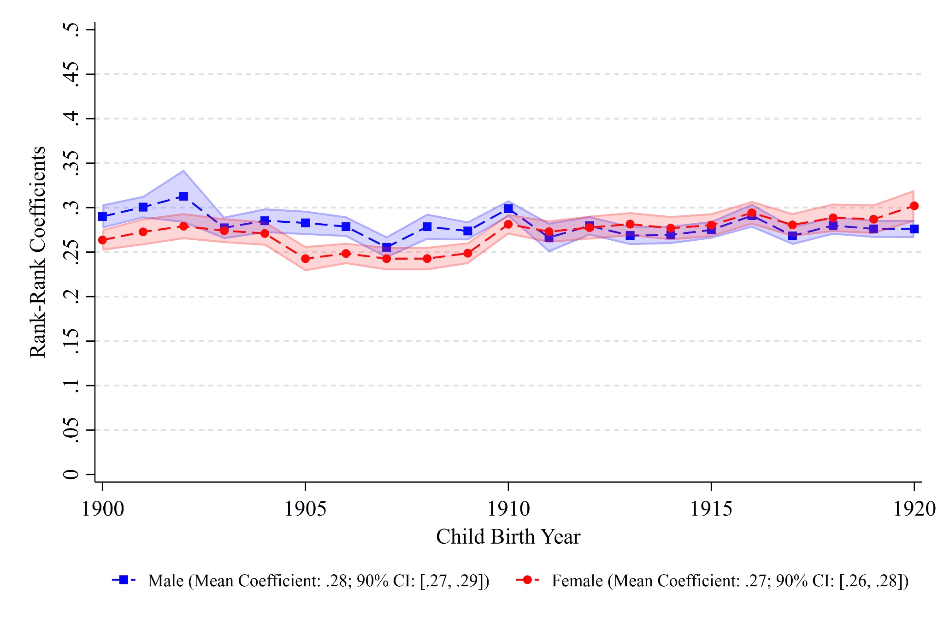

B. North Carolina

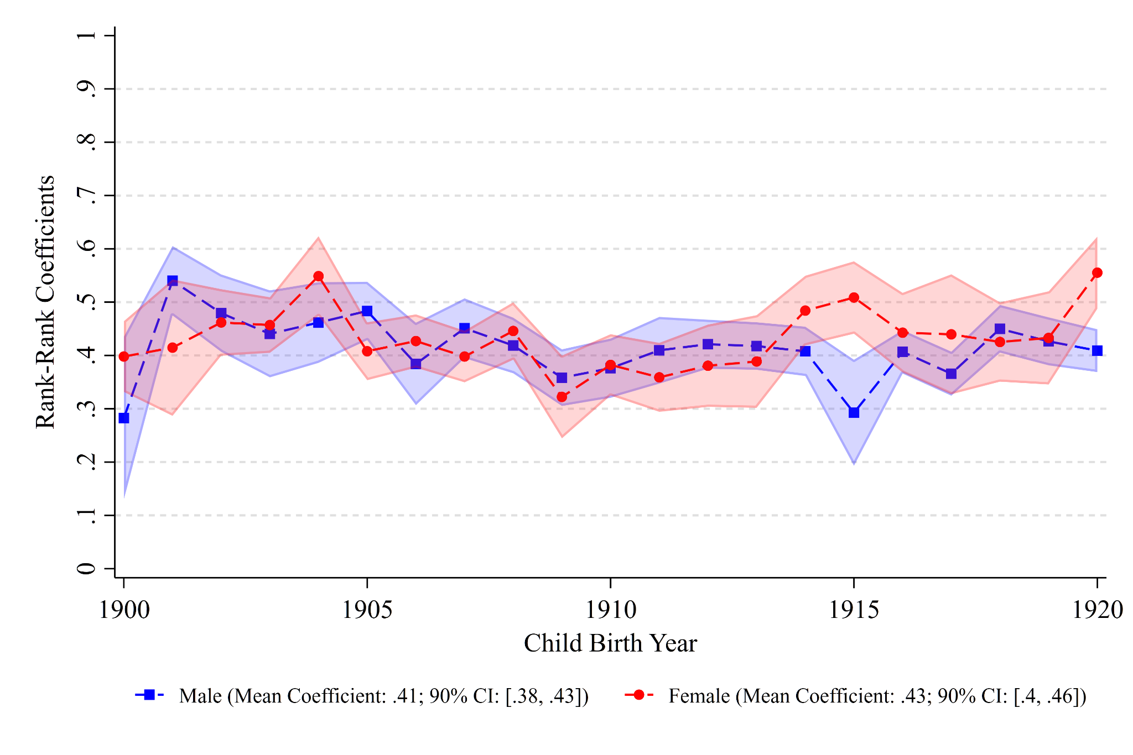

*Source*: Authors’ tabulation using the LIFE-M data (Bailey et al. 2022).

*Note*: Occupational ranks are based on the national distribution of occupational scores created by Collins and Wanamaker (2022). For more details, see figure 2 notes.

Figure A.2. Intergenerational Educational Persistence, by State of Birth, Cohort and Sex

A. Ohio

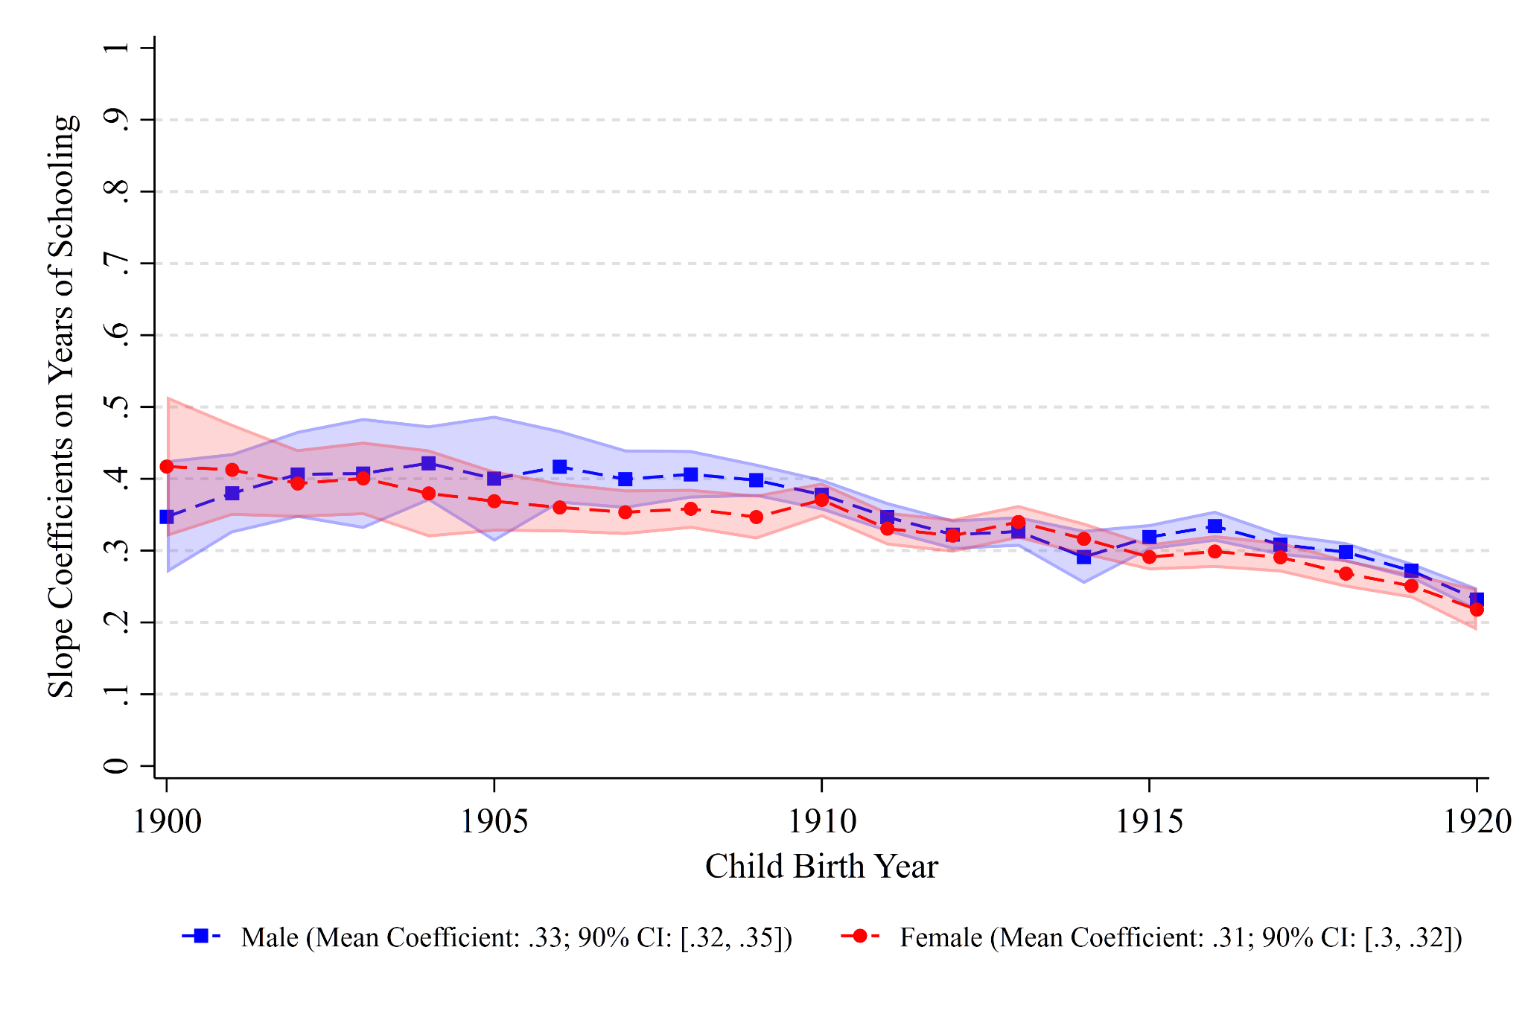

B. North Carolina

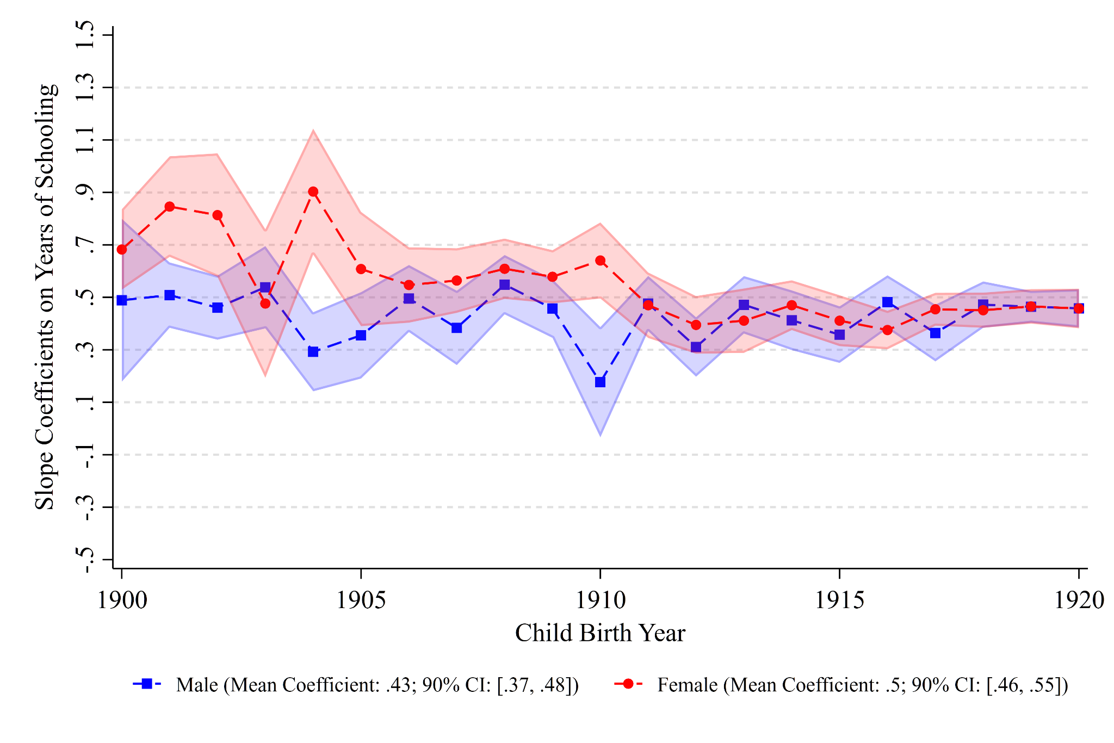

*Source*: Authors’ tabulation using the LIFE-M data (Bailey et al. 2022).

*Note*: For more details, see figure 2 notes.

Figure A.3. Heterogeneous Effects of Great Depression on Intergenerational Mobility, by Birth State and Sex

A. Ohio

B. North Carolina

*Source*: Authors’ tabulation using the LIFE-M data (Bailey et al. 2022).

*Note*: This figure plots heterogeneous effects of the Great Depression on intergenerational mobility by various community- and individual-level attributes for Ohio and North Carolina separately. For more details, see figure 3 notes.