Figure A1
Map of Matching U.S. Counties

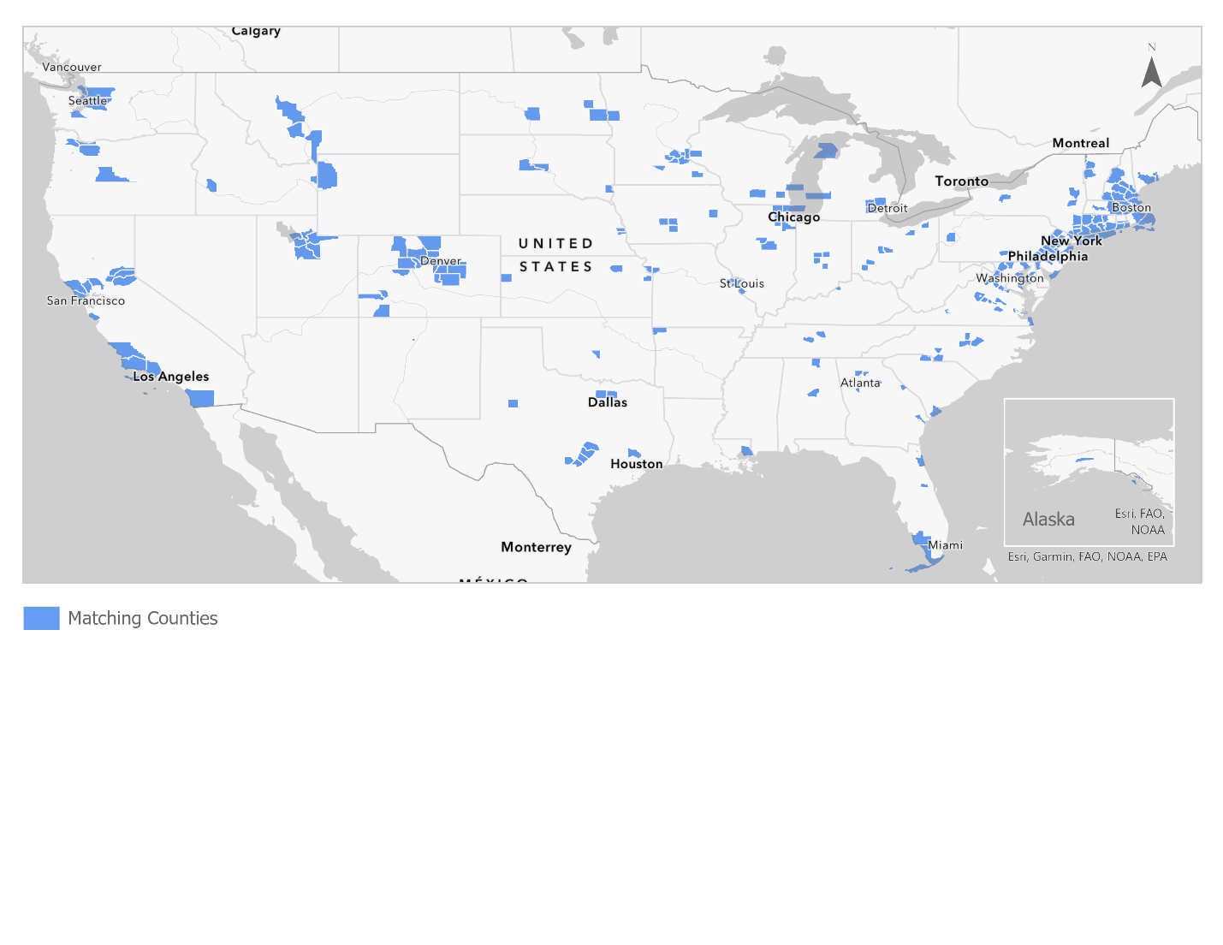
Map source: Authors' mapping projection and calculations conducted in ArcGIS Pro.
Data source: SimplyAnalytics & US Census Bureau American Community Survey Data.

