Online Appendix

Americans’ Trust in Government and Health Behaviors during the COVID-19 Pandemic

Elizabeth Suhay, Aparna Soni, Claudia Persico, and Dave E. Marcotte

Table of Contents
Appendix Figure 1. Trends in Trust Over Time, Using Dichotomous Measure of Trust 2
Appendix Figure 2. Trends in Trust Over Time by Partisanship and Socio-Economic Characteristics 3
Appendix Table 1. Surveys and Sample Sizes for Axios/Ipsos Coronavirus Poll 4
Appendix Table 2. Means of Outcome Variables for Subgroups 5
Appendix Table 3. Regression Results for Association Between Time, Socio-Demographic Characteristics, and Trust 6
Appendix Table 4. Replication of Appendix Table 3 without Controlling for Pandemic Severity and Policies 8
Appendix Table 5. Replication of Appendix Table 3 without State Fixed Effects 10
Appendix Table 6. Replication of Appendix Table 3 with Dichotomous Measures of Trust 12
Appendix Table 7. Replication of Table 2 without Controlling for Pandemic Severity and Policies 14
Appendix Table 8. Replication of Table 2 without State Fixed Effects 16
Appendix Table 9. Replication of Table 2 using Dichotomous Measures of Trust 18
Appendix Table 10. Regression Results for How Socio-Demographic Correlates of Trust Changed Over Time 20
Appendix Table 11. Replication of Appendix Table 10 without Controlling for Pandemic Severity and Policies 23
Appendix Table 12. Replication of Appendix Table 10 without State Fixed Effects 25
Appendix Table 13. Replication of Appendix Table 10 with Dichotomous Measures of Trust 28
Appendix Table 14. Regression Results for Association Between Trust and Protective Health Behaviors 31
Appendix Table 15. Replication of Appendix Table 14 with Dichotomous Measures 33
Appendix Table 16. Replication of Appendix Table 14 without Controlling for Pandemic Severity and Policies 35
Appendix Table 17. Replication of Appendix Table 14 Stratified by Partisanship 37
Appendix Table 18. Replication of Appendix Table 17 without Controlling for Pandemic Severity and Policies 42
Appendix Table 19. Replication of Appendix Table 14 Stratified by Match Between Party ID of Respondent and State Governor 46

Appendix Figure 1. Trends in Trust Over Time, Using Dichotomous Measure of Trust

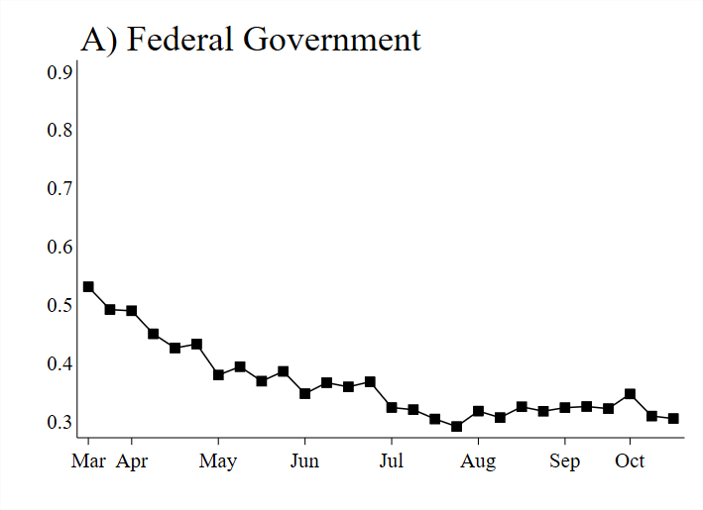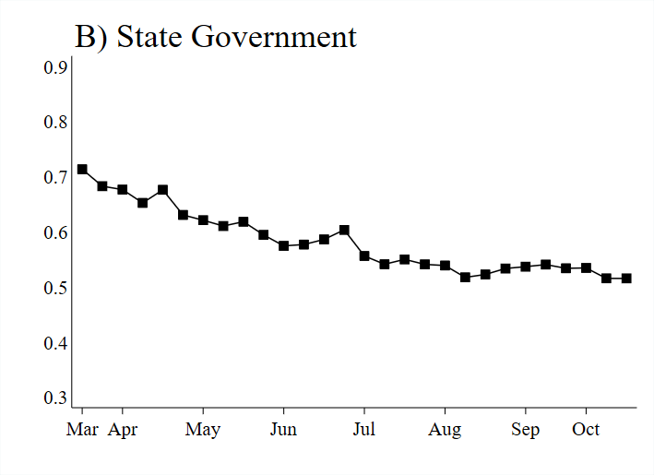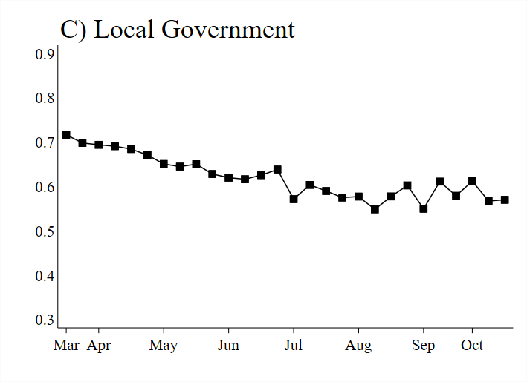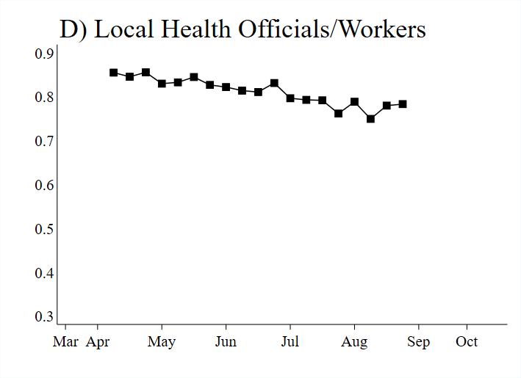
Source: Authors’ calculations based on Surveys 2 through 29 of the 2020 Axios/Ipsos Coronavirus Poll (administered March 20 to October 26, 2020). N=29,671. Figures display (weighted) proportion of sample with “fair amount” or “great deal” of trust in the institution. Vertical axis measures the proportion of respondents; x-axis displays day of interview. All analyses use Axios/Ipsos survey weights.

Appendix Figure 2. Trends in Trust Over Time by Partisanship and Socio-Economic Characteristics

A) By Partisanship
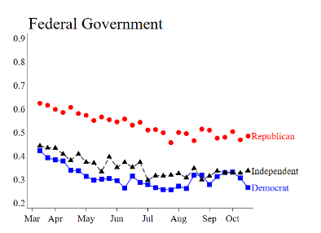
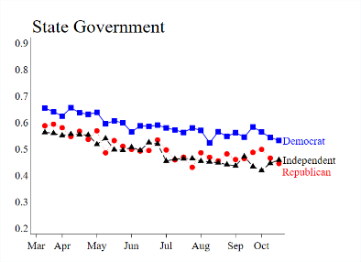
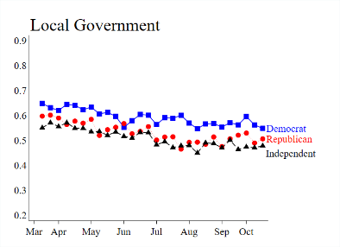
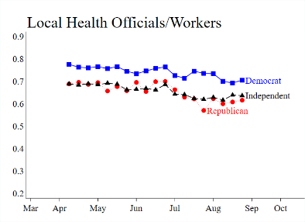
B) By Age
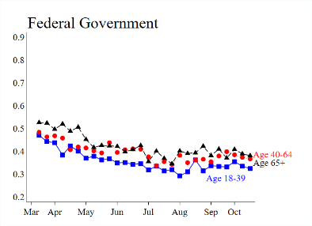
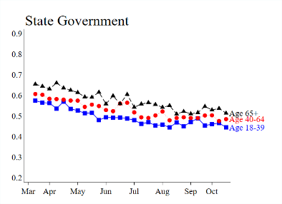
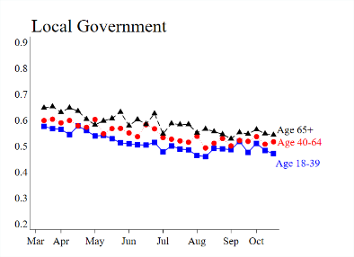
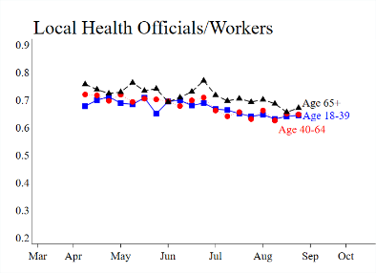
C) By Race/Ethnicity
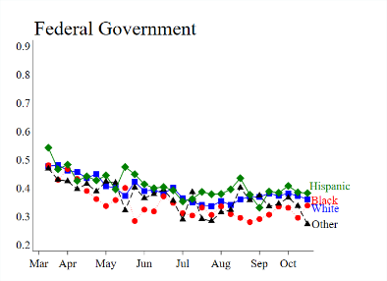
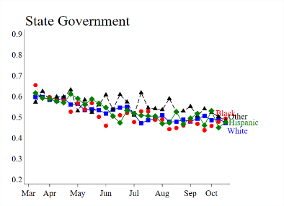
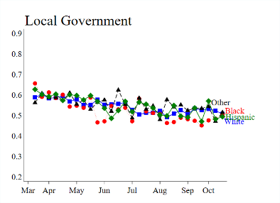
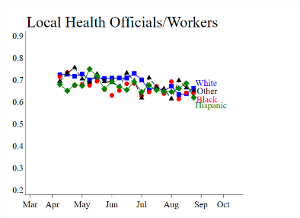
D) By Income
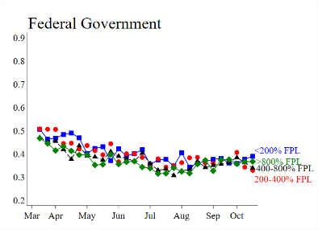
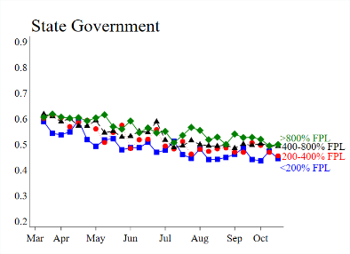
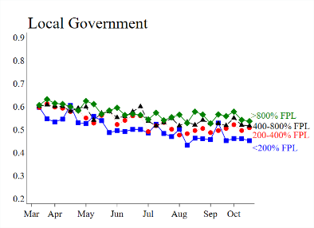
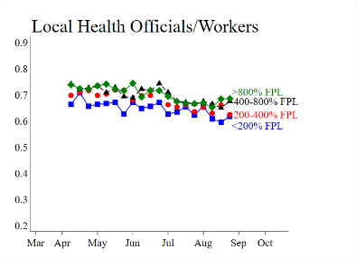
Source: Authors’ calculations based on Surveys 2 through 29 of the 2020 Axios/Ipsos Coronavirus Poll (administered March 20 to October 26, 2020). N=29,671. Trust is measured on a continuous scale from 0 to 1, with 0 representing no trust at all in the institution to look out for you and your family, and 1 representing a great deal of trust. Vertical axis measures the weighted mean; x-axis displays week of interview. All analyses use Axios/Ipsos survey weights. An alternative version of these figures that uses dichotomous measures of trust is available on request.

Appendix Table 1. Surveys and Sample Sizes for Axios/Ipsos Coronavirus Poll
Survey | Interview Dates | Sample Size
1 | March 13 – March 16, 2020 | [Not used]
2 | March 20 – March 23, 2020 | 998
3 | March 27 – March 30, 2020 | 1,355
4 | April 3 – April 6, 2020 | 1,136
5 | April 10 – April 13, 2020 | 1,098
6 | April 17 – April 20, 2020 | 1,021
7 | April 24 – April 27, 2020 | 1,021
8 | May 1 – May 4, 2020 | 1,012
9 | May 8 – May 11, 2020 | 980
10 | May 15 – May 18, 2020 | 1,009
11 | May 29 – June 1, 2020 | 1,033
12 | June 5 – June 8, 2020 | 1,006
13 | June 12 – June 15, 2020 | 1,022
14 | June 19 – June 22, 2020 | 1,023
15 | June 26 – June 29, 2020 | 1,065
16 | July 10 – July 13, 2020 | 1,063
17 | July 17 – July 20, 2020 | 1,037
18 | July 24 – July 27, 2020 | 1,076
19 | July 31 – August 3, 2020 | 1,129
20 | August 7 – August 10, 2020 | 1,076
21 | August 14 – August 17, 2020 | 1,141
22 | August 21 – August 24, 2020 | 1,084
23 | August 28 – August 31, 2020 | 1,100
24 | September 11 – September 14, 2020 | 1,019
25 | September 18 – September 21, 2020 | 1,008
26 | September 24 – September 27, 2020 | 1,075
27 | October 1 – October 5, 2020 | 1,004
28 | October 16 – October 19, 2020 | 1,001
29 | October 23 – October 26, 2020 | 1,079
Total |  | 29,671
Source: Authors’ calculations based on 2020 Axios/Ipsos Coronavirus Poll.

Appendix Table 2. Means of Outcome Variables for Subgroups
 | Trust federal government | Trust state government | Trust local government | Trust local health officials/workers | Wear mask | Maintain 6-foot distance | Social distanced in past week
Political Affiliation
Democrat | 0.31 | 0.59 | 0.59 | 0.74 | 0.88 | 0.87 | 0.88
Republican | 0.53 | 0.50 | 0.53 | 0.65 | 0.67 | 0.74 | 0.70
Independent | 0.36 | 0.49 | 0.51 | 0.66 | 0.76 | 0.80 | 0.79
Educational Attainment
Less than high school | 0.43 | 0.51 | 0.52 | 0.63 | 0.78 | 0.82 | 0.79
High school | 0.42 | 0.51 | 0.52 | 0.66 | 0.75 | 0.80 | 0.77
Some college | 0.39 | 0.51 | 0.53 | 0.68 | 0.77 | 0.80 | 0.78
College or more | 0.35 | 0.56 | 0.58 | 0.73 | 0.79 | 0.82 | 0.83
Household Income
<200% FPL | 0.40 | 0.49 | 0.50 | 0.65 | 0.78 | 0.83 | 0.82
200-400% FPL | 0.40 | 0.52 | 0.54 | 0.68 | 0.77 | 0.81 | 0.79
400-800% FPL | 0.38 | 0.53 | 0.56 | 0.70 | 0.76 | 0.79 | 0.78
>800% FPL | 0.37 | 0.56 | 0.57 | 0.70 | 0.79 | 0.81 | 0.80
Race/ethnicity
White, non-Hispanic | 0.39 | 0.52 | 0.54 | 0.69 | 0.73 | 0.79 | 0.77
Black, non-Hispanic | 0.35 | 0.51 | 0.53 | 0.67 | 0.86 | 0.87 | 0.84
Other, non-Hispanic | 0.37 | 0.56 | 0.55 | 0.69 | 0.81 | 0.82 | 0.85
Hispanic | 0.41 | 0.53 | 0.55 | 0.67 | 0.86 | 0.86 | 0.83
Age
18-39 | 0.36 | 0.49 | 0.51 | 0.67 | 0.75 | 0.78 | 0.78
40-64 | 0.40 | 0.53 | 0.55 | 0.68 | 0.77 | 0.82 | 0.80
65+ | 0.42 | 0.57 | 0.59 | 0.72 | 0.83 | 0.84 | 0.84
Female | 0.39 | 0.53 | 0.55 | 0.70 | 0.81 | 0.83 | 0.82
Male | 0.38 | 0.52 | 0.54 | 0.67 | 0.73 | 0.79 | 0.77
Married | 0.40 | 0.54 | 0.56 | 0.69 | 0.77 | 0.81 | 0.79
Not Married | 0.37 | 0.52 | 0.53 | 0.68 | 0.78 | 0.80 | 0.81
Source: Authors’ calculations based on Surveys 2 through 29 of the 2020 Axios/Ipsos Coronavirus Poll (administered March 20 to October 26, 2020). All analyses use Axios/Ipsos survey weights.

Appendix Table 3. Regression Results for Association Between Time, Socio-Demographic Characteristics, and Trust
 | Federal Government | State Government | Local Government | Local Health Officials/Workers
Survey | -0.067***  (0.010) | -0.088***  (0.010) | -0.072***  (0.010) | -0.079***  (0.011)
Democrat | -0.052***  (0.004) | 0.092***  (0.004) | 0.082***  (0.004) | 0.086***  (0.004)
Republican | 0.178^{***,c}  (0.004) | 0.011^{**,c}  (0.004) | 0.016^{***,c}  (0.004) | -0.014^{***,c}  (0.005)
High School | -0.024***  (0.006) | -0.000  (0.006) | -0.005  (0.006) | 0.016**  (0.007)
Some College | -0.050***  (0.006) | -0.002  (0.006) | 0.004  (0.006) | 0.038***  (0.007)
College or More | -0.067***  (0.006) | 0.041***  (0.007) | 0.044***  (0.006) | 0.076***  (0.007)
Income <200% FPL | 0.021***  (0.005) | -0.016***  (0.005) | -0.024***  (0.005) | -0.022***  (0.006)
Income 200-400% FPL | 0.012***  (0.004) | 0.000  (0.005) | -0.005  (0.004) | -0.002  (0.005)
Income >800% FPL | 0.005  (0.005) | 0.004  (0.005) | 0.003  (0.005) | -0.012**  (0.005)
Black, non-Hispanic | 0.019***  (0.006) | -0.021***  (0.006) | -0.023***  (0.005) | -0.047***  (0.006)
Other Race, non-Hispanic | 0.020***  (0.006) | 0.031***  (0.006) | 0.007  (0.006) | -0.013*  (0.007)
Hispanic | 0.057***  (0.005) | 0.022***  (0.005) | 0.017***  (0.005) | -0.013**  (0.006)
Age 18-39 | -0.024***  (0.004) | -0.042***  (0.004) | -0.034***  (0.004) | -0.011**  (0.004)
Age 65+ | 0.029***  (0.004) | 0.047***  (0.005) | 0.043***  (0.004) | 0.033***  (0.005)
Female | 0.009***  (0.003) | 0.013***  (0.003) | 0.004  (0.003) | 0.023***  (0.004)
Married | 0.003  (0.004) | 0.003  (0.004) | 0.009**  (0.004) | 0.004  (0.004)
Household Size | 0.045***  (0.014) | -0.018  (0.015) | -0.005  (0.014) | -0.018  (0.016)
Logged Death Rate | 0.004  (0.009) | -0.011  (0.009) | -0.010  (0.009) | -0.007  (0.011)
Logged Case Rate | -0.012***  (0.003) | -0.008***  (0.003) | -0.004  (0.003) | -0.001  (0.004)
Mask Mandate in Effect | -0.015***  (0.006) | -0.016***  (0.006) | -0.010*  (0.005) | -0.003  (0.006)
Business Reopening in Effect | -0.021***  (0.005) | -0.015***  (0.005) | -0.011**  (0.004) | -0.003  (0.006)
Stay at Home Order in Effect | -0.004  (0.006) | 0.000  (0.006) | 0.005  (0.006) | -0.005  (0.008)
N | 29,176 | 29,188 | 29,178 | 19,667
Mean of Outcome | 0.39 | 0.52 | 0.54 | 0.68
Source: Authors’ calculations based on Surveys 2 through 29 of the 2020 Axios/Ipsos Coronavirus Poll (administered March 20 to October 26, 2020). Each column presents linear regression results from a different regression; column header indicates outcome variable. Trust is measured on a continuous scale from 0 to 1, with 0 representing no trust at all in the institution to look out for you and your family, and 1 representing a great deal of trust. All regressions also include state fixed effects and use Axios/Ipsos survey weights. The variables “Independent” party ID, “Less than high school” educational attainment, “Income 400-800% FPL,” “White, non-Hispanic” race, and “Age 40-64” are omitted as base categories. Standard errors in parentheses. This table corresponds to Figure 2 in the main paper.
* p < 0.10, ** p < 0.05, *** p < 0.01
Coefficient for Republican is significantly different from that of Democrat with ª p < 0.10, ^{b} p < 0.05, ^{c} p < 0.01

Appendix Table 4. Replication of Appendix Table 3 without Controlling for Pandemic Severity and Policies
 | Federal Government | State Government | Local Government | Local Health Officials/Workers
Survey | -0.113***  (0.005) | -0.125***  (0.006) | -0.098***  (0.005) | -0.078***  (0.006)
Democrat | -0.052***  (0.004) | 0.092***  (0.004) | 0.082***  (0.004) | 0.086***  (0.004)
Republican | 0.178^{***,c}  (0.004) | 0.011^{**,c}  (0.004) | 0.016^{***,c}  (0.004) | -0.014^{***,c}  (0.005)
High School | -0.024***  (0.006) | -0.000  (0.006) | -0.005  (0.006) | 0.016**  (0.007)
Some College | -0.050***  (0.006) | -0.002  (0.006) | 0.004  (0.006) | 0.038***  (0.007)
College or More | -0.067***  (0.006) | 0.041***  (0.007) | 0.044***  (0.006) | 0.076***  (0.007)
Income <200% FPL | 0.020***  (0.005) | -0.016***  (0.005) | -0.024***  (0.005) | -0.022***  (0.006)
Income 200-400% FPL | 0.012***  (0.004) | 0.001  (0.005) | -0.005  (0.004) | -0.002  (0.005)
Income >800% FPL | 0.005  (0.005) | 0.003  (0.005) | 0.003  (0.005) | -0.012**  (0.005)
Black, non-Hispanic | 0.019***  (0.006) | -0.021***  (0.006) | -0.023***  (0.005) | -0.047***  (0.006)
Other Race, non-Hispanic | 0.021***  (0.006) | 0.032***  (0.006) | 0.007  (0.006) | -0.013*  (0.007)
Hispanic | 0.057***  (0.005) | 0.022***  (0.005) | 0.017***  (0.005) | -0.013**  (0.006)
Age 18-39 | -0.024***  (0.004) | -0.042***  (0.004) | -0.035***  (0.004) | -0.011**  (0.004)
Age 65+ | 0.029***  (0.004) | 0.047***  (0.005) | 0.042***  (0.004) | 0.033***  (0.005)
Female | 0.009***  (0.003) | 0.013***  (0.003) | 0.004  (0.003) | 0.023***  (0.004)
Married | 0.004  (0.004) | 0.003  (0.004) | 0.009**  (0.004) | 0.005  (0.004)
Household Size | 0.044***  (0.014) | -0.018  (0.015) | -0.005  (0.014) | -0.018  (0.016)
N | 29,176 | 29,188 | 29,178 | 19,667
Mean of Outcome | 0.39 | 0.52 | 0.54 | 0.68
Source: Authors’ calculations based on Surveys 2 through 29 of the 2020 Axios/Ipsos Coronavirus Poll (administered March 20 to October 26, 2020). Each column presents linear regression results from a different regression; column header indicates outcome variable. Trust is measured on a continuous scale from 0 to 1, with 0 representing no trust at all in the institution to look out for you and your family, and 1 representing a great deal of trust. All regressions also include state fixed effects and use Axios/Ipsos survey weights. The variables “Independent” party ID, “Less than high school” educational attainment, “Income 400-800% FPL,” “White, non-Hispanic” race, and “Age 40-64” are omitted as base categories. Standard errors in parentheses.
* p < 0.10, ** p < 0.05, *** p < 0.01
Coefficient for Republican is significantly different from that of Democrat with ª p < 0.10, ^{b} p < 0.05, ^{c} p < 0.01

Appendix Table 5. Replication of Appendix Table 3 without State Fixed Effects
 | Federal Government | State Government | Local Government | Local Health Officials/Workers
Survey | -0.089***  (0.009) | -0.124***  (0.009) | -0.101***  (0.009) | -0.089***  (0.010)
Democrat | -0.051***  (0.004) | 0.093***  (0.004) | 0.081***  (0.004) | 0.086***  (0.004)
Republican | 0.180^{***,c}  (0.004) | 0.005^{c}  (0.004) | 0.013^{***,c}  (0.004) | -0.017^{***,c}  (0.005)
High School | -0.023***  (0.006) | 0.001  (0.006) | -0.002  (0.006) | 0.017**  (0.007)
Some College | -0.052***  (0.006) | -0.002  (0.006) | 0.006  (0.006) | 0.040***  (0.007)
College or More | -0.067***  (0.006) | 0.043***  (0.007) | 0.047***  (0.006) | 0.079***  (0.007)
Income <200% FPL | 0.020***  (0.005) | -0.021***  (0.005) | -0.027***  (0.005) | -0.023***  (0.006)
Income 200-400% FPL | 0.012***  (0.004) | -0.001  (0.005) | -0.007  (0.004) | -0.003  (0.005)
Income >800% FPL | 0.006  (0.005) | 0.006  (0.005) | 0.005  (0.005) | -0.012**  (0.005)
Black, non-Hispanic | 0.025***  (0.006) | -0.027***  (0.006) | -0.027***  (0.005) | -0.050***  (0.006)
Other Race, non-Hispanic | 0.019***  (0.006) | 0.024***  (0.006) | 0.003  (0.006) | -0.016**  (0.007)
Hispanic | 0.054***  (0.005) | 0.008  (0.005) | 0.012***  (0.005) | -0.017***  (0.006)
Age 18-39 | -0.025***  (0.004) | -0.038***  (0.004) | -0.033***  (0.004) | -0.009**  (0.004)
Age 65+ | 0.029***  (0.004) | 0.046***  (0.005) | 0.042***  (0.004) | 0.033***  (0.005)
Female | 0.009***  (0.003) | 0.012***  (0.003) | 0.004  (0.003) | 0.023***  (0.004)
Married | 0.003  (0.004) | 0.003  (0.004) | 0.009**  (0.004) | 0.005  (0.004)
Household Size | 0.045***  (0.014) | -0.016  (0.015) | -0.004  (0.014) | -0.018  (0.016)
Logged Death Rate | 0.002  (0.008) | 0.004  (0.008) | 0.001  (0.007) | -0.006  (0.008)
Logged Case Rate | -0.008***  (0.003) | -0.016***  (0.003) | -0.007***  (0.002) | -0.001  (0.003)
Mask Mandate in Effect | -0.006  (0.004) | 0.035***  (0.004) | 0.018***  (0.004) | 0.007  (0.005)
Business Reopening in Effect | -0.011***  (0.004) | 0.010**  (0.004) | 0.001  (0.004) | 0.002  (0.005)
Stay at Home Order in Effect | -0.003  (0.004) | 0.025***  (0.004) | 0.007*  (0.004) | -0.005  (0.005)
N | 29,176 | 29,188 | 29,178 | 19,667
Mean of Outcome | 0.39 | 0.52 | 0.54 | 0.68
Source: Authors’ calculations based on Surveys 2 through 29 of the 2020 Axios/Ipsos Coronavirus Poll (administered March 20 to October 26, 2020). Each column presents linear regression results from a different regression; column header indicates outcome variable. Trust is measured on a continuous scale from 0 to 1, with 0 representing no trust at all in the institution to look out for you and your family, and 1 representing a great deal of trust. All regressions use Axios/Ipsos survey weights. The variables “Independent” party ID, “Less than high school” educational attainment, “Income 400-800% FPL,” “White, non-Hispanic” race, and “Age 40-64” are omitted as base categories. Standard errors in parentheses.
* p < 0.10, ** p < 0.05, *** p < 0.01
Coefficient for Republican is significantly different from that of Democrat with ª p < 0.10, ^{b} p < 0.05, ^{c} p < 0.01

Appendix Table 6. Replication of Appendix Table 3 with Dichotomous Measures of Trust
 | Federal Government | State Government | Local Government | Local Health Officials/Workers
Survey | -0.124***  (0.016) | -0.124***  (0.017) | -0.089***  (0.017) | -0.081***  (0.017)
Democrat | -0.070***  (0.006) | 0.135***  (0.007) | 0.134***  (0.007) | 0.099***  (0.007)
Republican | 0.268^{***,c}  (0.007) | 0.027^{***,c}  (0.007) | 0.029^{***,c}  (0.007) | -0.012^{c}  (0.007)
High School | -0.032***  (0.010) | -0.004  (0.010) | -0.005  (0.010) | 0.028***  (0.010)
Some College | -0.072***  (0.010) | -0.004  (0.011) | 0.011  (0.011) | 0.057***  (0.010)
College or More | -0.111***  (0.011) | 0.055***  (0.011) | 0.076***  (0.011) | 0.095***  (0.011)
Income <200% FPL | 0.034***  (0.008) | -0.025***  (0.009) | -0.045***  (0.009) | -0.029***  (0.008)
Income 200-400% FPL | 0.016**  (0.007) | -0.003  (0.008) | -0.019**  (0.008) | 0.003  (0.008)
Income >800% FPL | 0.006  (0.008) | 0.016**  (0.008) | 0.007  (0.008) | -0.016**  (0.008)
Black, non-Hispanic | 0.032***  (0.009) | -0.032***  (0.010) | -0.047***  (0.010) | -0.057***  (0.010)
Other Race, non-Hispanic | 0.024**  (0.010) | 0.052***  (0.011) | 0.018*  (0.010) | -0.006  (0.010)
Hispanic | 0.087***  (0.009) | 0.032***  (0.009) | 0.016*  (0.009) | -0.020**  (0.009)
Age 18-39 | -0.039***  (0.006) | -0.056***  (0.007) | -0.048***  (0.007) | -0.011*  (0.007)
Age 65+ | 0.045***  (0.007) | 0.070***  (0.008) | 0.067***  (0.008) | 0.038***  (0.008)
Female | 0.013**  (0.005) | 0.023***  (0.006) | 0.011**  (0.006) | 0.038***  (0.006)
Married | 0.007  (0.006) | 0.002  (0.006) | 0.019***  (0.006) | 0.008  (0.006)
Household Size | 0.051**  (0.024) | -0.025  (0.025) | -0.021  (0.025) | -0.009  (0.024)
Logged Death Rate | 0.004  (0.015) | -0.033**  (0.015) | -0.032**  (0.015) | -0.017  (0.016)
Logged Case Rate | -0.015***  (0.005) | -0.014***  (0.005) | -0.005  (0.005) | -0.006  (0.005)
Mask Mandate in Effect | -0.019**  (0.009) | -0.009  (0.010) | -0.014  (0.010) | -0.004  (0.010)
Business Reopening in Effect | -0.035***  (0.008) | -0.030***  (0.008) | -0.029***  (0.008) | -0.015*  (0.008)
Stay at Home Order in Effect | -0.010  (0.010) | 0.006  (0.010) | 0.015  (0.010) | -0.005  (0.012)
N | 29,176 | 29,188 | 29,178 | 19,667
Mean of Outcome | 0.37 | 0.58 | 0.62 | 0.81
Source: Authors’ calculations based on Surveys 2 through 29 of the 2020 Axios/Ipsos Coronavirus Poll (administered March 20 to October 26, 2020). Each column presents linear regression results from a different regression; column header indicates outcome variable. Trust is a dichotomous variable equal to 1 if the respondent has a “fair amount” or “great deal” of trust in the institution to look out for them and their family, and 0 if they have “not very much” trust or “none at all.” All regressions also include state fixed effects and use Axios/Ipsos survey weights. The variables “Independent” party ID, “Less than high school” educational attainment, “Income 400-800% FPL,” “White, non-Hispanic” race, and “Age 40-64” are omitted as base categories. Standard errors in parentheses.
* p < 0.10, ** p < 0.05, *** p < 0.01
Coefficient for Republican is significantly different from that of Democrat with ª p < 0.10, ^{b} p < 0.05, ^{c} p < 0.01

Appendix Table 7. Replication of Table 2 without Controlling for Pandemic Severity and Policies
 | Federal Government | State Government | Local Government | Local Health Officials/Workers
Spring Survey | -0.095***  (0.008) | -0.066***  (0.009) | -0.045***  (0.008) | -0.022**  (0.009)
Summer Survey | -0.036^{***,+++}  (0.008) | -0.052***  (0.008) | -0.042***  (0.008) | -0.062^{***,+++}  (0.007)
Fall Survey | -0.003⁺⁺⁺  (0.010) | -0.011⁺⁺⁺  (0.011) | -0.000⁺⁺⁺  (0.010) | -
Democrat | -0.052***  (0.004) | 0.092***  (0.004) | 0.082***  (0.004) | 0.086***  (0.004)
Republican | 0.178^{***,c}  (0.004) | 0.011^{**,c}  (0.004) | 0.016^{***,c}  (0.004) | -0.014^{***,c}  (0.005)
High school | -0.024***  (0.006) | -0.000  (0.006) | -0.005  (0.006) | 0.016**  (0.007)
Some college | -0.050***  (0.006) | -0.002  (0.006) | 0.004  (0.006) | 0.038***  (0.007)
College or more | -0.067***  (0.006) | 0.041***  (0.007) | 0.044***  (0.006) | 0.076***  (0.007)
Income <200% FPL | 0.021***  (0.005) | -0.016***  (0.005) | -0.024***  (0.005) | -0.022***  (0.006)
Income 200-400% FPL | 0.013***  (0.004) | 0.001  (0.005) | -0.005  (0.004) | -0.002  (0.005)
Income >800% FPL | 0.005  (0.005) | 0.004  (0.005) | 0.003  (0.005) | -0.012**  (0.005)
Black, non-Hispanic | 0.019***  (0.006) | -0.022***  (0.006) | -0.023***  (0.005) | -0.047***  (0.006)
Other, non-Hispanic | 0.021***  (0.006) | 0.032***  (0.006) | 0.007  (0.006) | -0.013*  (0.007)
Hispanic | 0.057***  (0.005) | 0.022***  (0.005) | 0.017***  (0.005) | -0.013**  (0.006)
Age 18-39 | -0.025***  (0.004) | -0.042***  (0.004) | -0.035***  (0.004) | -0.011**  (0.004)
Age 65+ | 0.029***  (0.004) | 0.047***  (0.005) | 0.043***  (0.004) | 0.033***  (0.005)
Female | 0.009***  (0.003) | 0.013***  (0.003) | 0.004  (0.003) | 0.023***  (0.004)
Married | 0.003  (0.004) | 0.003  (0.004) | 0.009**  (0.004) | 0.005  (0.004)
Household size | 0.045***  (0.014) | -0.017  (0.015) | -0.005  (0.014) | -0.018  (0.016)
N | 29,176 | 29,188 | 29,178 | 19,667
Mean of Outcome | 0.39 | 0.52 | 0.54 | 0.68
Source: Authors’ calculations based on Surveys 2 through 29 of the 2020 Axios/Ipsos Coronavirus Poll (administered March 20 to October 26, 2020). Each column presents linear regression results from a different regression; column header indicates outcome variable. Trust is measured on a continuous scale from 0 to 1, with 0 representing no trust at all in the institution to look out for you and your family, and 1 representing a great deal of trust. All regressions also include state fixed effects and use Axios/Ipsos survey weights. The variables “Independent” party ID, “Less than high school” educational attainment, “Income 400-800% FPL,” “White, non-Hispanic” race, and “Age 40-64” are omitted as base categories. Standard errors in parentheses.
* p < 0.10, ** p < 0.05, *** p < 0.01
Coefficient for summer or fall survey is significantly different from that of spring survey with ⁺ p < 0.10, ⁺⁺ p < 0.05, ⁺⁺⁺ p < 0.01
Coefficient for Republican is significantly different from that of Democrat with ª p < 0.10, ^{b} p < 0.05, ^{c} p < 0.01

Appendix Table 8. Replication of Table 2 without State Fixed Effects
 | Federal government | State Government | Local Government | Local Health Officials/Workers
Spring Survey | -0.109***  (0.010) | -0.098***  (0.010) | -0.061***  (0.010) | -0.023**  (0.010)
Summer Survey | -0.031^{***,+++}  (0.009) | -0.055^{***,+++}  (0.009) | -0.048***  (0.008) | -0.065^{***,+++}  (0.008)
Fall Survey | -0.001⁺⁺⁺  (0.010) | -0.002⁺⁺⁺  (0.011) | 0.003⁺⁺⁺  (0.010) | -
Democrat | -0.051***  (0.004) | 0.093***  (0.004) | 0.081***  (0.004) | 0.086***  (0.004)
Republican | 0.180^{***,c}  (0.004) | 0.006^{c}  (0.004) | 0.013^{***,c}  (0.004) | -0.017^{***,c}  (0.005)
High school | -0.024***  (0.006) | 0.001  (0.006) | -0.003  (0.006) | 0.018**  (0.007)
Some college | -0.051***  (0.006) | -0.002  (0.006) | 0.006  (0.006) | 0.040***  (0.007)
College or more | -0.067***  (0.006) | 0.044***  (0.007) | 0.048***  (0.006) | 0.079***  (0.007)
Income <200% FPL | 0.021***  (0.005) | -0.020***  (0.005) | -0.027***  (0.005) | -0.023***  (0.006)
Income 200-400% FPL | 0.013***  (0.004) | -0.000  (0.005) | -0.006  (0.004) | -0.003  (0.005)
Income >800% FPL | 0.005  (0.005) | 0.006  (0.005) | 0.005  (0.005) | -0.012**  (0.005)
Black, non-Hispanic | 0.024***  (0.006) | -0.028***  (0.006) | -0.028***  (0.005) | -0.050***  (0.006)
Other race, non-Hispanic | 0.020***  (0.006) | 0.025***  (0.006) | 0.003  (0.006) | -0.016**  (0.007)
Hispanic | 0.057***  (0.005) | 0.009*  (0.005) | 0.013***  (0.005) | -0.017***  (0.006)
Age 18-39 | -0.026***  (0.004) | -0.039***  (0.004) | -0.033***  (0.004) | -0.009**  (0.004)
Age 65+ | 0.029***  (0.004) | 0.046***  (0.005) | 0.042***  (0.004) | 0.033***  (0.005)
Female | 0.010***  (0.003) | 0.012***  (0.003) | 0.004  (0.003) | 0.022***  (0.004)
Married | 0.003  (0.004) | 0.003  (0.004) | 0.008**  (0.004) | 0.005  (0.004)
Household size | 0.046***  (0.014) | -0.015  (0.015) | -0.003  (0.014) | -0.018  (0.016)
Logged Death Rate | 0.002  (0.008) | 0.005  (0.008) | -0.001  (0.007) | -0.004  (0.008)
Logged Case Rate | -0.002  (0.003) | -0.013***  (0.003) | -0.004  (0.003) | -0.002  (0.003)
Mask Mandate in Effect | 0.005  (0.004) | 0.042***  (0.004) | 0.024***  (0.004) | 0.006  (0.005)
Business Reopening in Effect | 0.017***  (0.005) | 0.028***  (0.005) | 0.013***  (0.005) | -0.002  (0.006)
Stay at Home Order in Effect | 0.001  (0.005) | 0.027***  (0.005) | 0.006  (0.004) | -0.004  (0.005)
N | 29,176 | 29,188 | 29,178 | 19,667
Mean of Outcome | 0.39 | 0.52 | 0.54 | 0.68
Source: Authors’ calculations based on Surveys 2 through 29 of the 2020 Axios/Ipsos Coronavirus Poll (administered March 20 to October 26, 2020). Each column presents linear regression results from a different regression; column header indicates outcome variable. Trust is measured on a continuous scale from 0 to 1, with 0 representing no trust at all in the institution to look out for you and your family, and 1 representing a great deal of trust. All regressions use Axios/Ipsos survey weights. The variables “Independent” party ID, “Less than high school” educational attainment, “Income 400-800% FPL,” “White, non-Hispanic” race, and “Age 40-64” are omitted as base categories. Standard errors in parentheses.
* p < 0.10, ** p < 0.05, *** p < 0.01
Coefficient for summer or fall survey is significantly different from that of spring survey with ⁺ p < 0.10, ⁺⁺ p < 0.05, ⁺⁺⁺ p < 0.01
Coefficient for Republican is significantly different from that of Democrat with ª p < 0.10, ^{b} p < 0.05, ^{c} p < 0.01

Appendix Table 9. Replication of Table 2 using Dichotomous Measures of Trust
 | Federal government | State Government | Local Government | Local Health Officials/Workers
Spring Survey | -0.165***  (0.018) | -0.081***  (0.018) | -0.058***  (0.018) | -0.013  (0.016)
Summer Survey | -0.045^{***,+++}  (0.015) | -0.059***  (0.015) | -0.047***  (0.015) | -0.057^{***,++}  (0.013)
Fall Survey | -0.012⁺⁺⁺  (0.017) | -0.017⁺⁺  (0.018) | 0.005⁺⁺  (0.018) | -
Democrat | -0.070***  (0.006) | 0.135***  (0.007) | 0.134***  (0.007) | 0.099***  (0.007)
Republican | 0.268^{***,c}  (0.007) | 0.027^{***,c}  (0.007) | 0.029^{***,c}  (0.007) | -0.012^{*,c}  (0.007)
High school | -0.032***  (0.010) | -0.004  (0.010) | -0.005  (0.010) | 0.028***  (0.010)
Some college | -0.072***  (0.010) | -0.004  (0.011) | 0.011  (0.011) | 0.057***  (0.010)
College or more | -0.111***  (0.010) | 0.055***  (0.011) | 0.076***  (0.011) | 0.095***  (0.011)
Income <200% FPL | 0.035***  (0.008) | -0.025***  (0.009) | -0.045***  (0.009) | -0.029***  (0.008)
Income 200-400% FPL | 0.017**  (0.007) | -0.002  (0.008) | -0.018**  (0.008) | 0.003  (0.008)
Income >800% FPL | 0.006  (0.008) | 0.016**  (0.008) | 0.007  (0.008) | -0.016**  (0.008)
Black, non-Hispanic | 0.032***  (0.009) | -0.032***  (0.010) | -0.047***  (0.010) | -0.057***  (0.010)
Other race, non-Hispanic | 0.024**  (0.010) | 0.052***  (0.011) | 0.018*  (0.010) | -0.006  (0.010)
Hispanic | 0.087***  (0.008) | 0.032***  (0.009) | 0.016*  (0.009) | -0.020**  (0.009)
Age 18-39 | -0.040***  (0.006) | -0.056***  (0.007) | -0.048***  (0.007) | -0.011*  (0.007)
Age 65+ | 0.045***  (0.007) | 0.070***  (0.008) | 0.067***  (0.008) | 0.038***  (0.008)
Female | 0.013**  (0.005) | 0.023***  (0.006) | 0.011**  (0.006) | 0.038***  (0.006)
Married | 0.007  (0.006) | 0.002  (0.006) | 0.019***  (0.006) | 0.008  (0.006)
Household size | 0.050**  (0.024) | -0.024  (0.025) | -0.021  (0.025) | -0.008  (0.024)
Logged Death Rate | 0.012  (0.015) | -0.031**  (0.016) | -0.030*  (0.016) | -0.016  (0.016)
Logged Case Rate | -0.009*  (0.005) | -0.011**  (0.005) | -0.003  (0.005) | -0.007  (0.006)
Mask Mandate in Effect | 0.001  (0.010) | 0.001  (0.010) | -0.005  (0.010) | -0.005  (0.010)
Business Reopening in Effect | 0.015  (0.010) | -0.013  (0.010) | -0.016  (0.010) | -0.020**  (0.010)
Stay at Home Order in Effect | 0.005  (0.011) | 0.007  (0.012) | 0.015  (0.012) | -0.005  (0.012)
N | 29,176 | 29,188 | 29,178 | 19,667
Mean of Outcome | 0.37 | 0.58 | 0.62 | 0.81
Source: Authors’ calculations based on Surveys 2 through 29 of the 2020 Axios/Ipsos Coronavirus Poll (administered March 20 to October 26, 2020). Each column presents linear regression results from a different regression; column header indicates outcome variable. Trust is a dichotomous variable equal to 1 if the respondent has a “fair amount” or “great deal” of trust in the institution to look out for them and their family, and 0 if they have “not very much” trust or “none at all.” All regressions also include state fixed effects and use Axios/Ipsos survey weights. The variables “Independent” party ID, “Less than high school” educational attainment, “Income 400-800% FPL,” “White, non-Hispanic” race, and “Age 40-64” are omitted as base categories. Standard errors in parentheses.
* p < 0.10, ** p < 0.05, *** p < 0.01
Coefficient for summer or fall survey is significantly different from that of spring survey with ⁺ p < 0.10, ⁺⁺ p < 0.05, ⁺⁺⁺ p < 0.01
Coefficient for Republican is significantly different from that of Democrat with ª p < 0.10, ^{b} p < 0.05, ^{c} p < 0.01

Appendix Table 10. Regression Results for How Socio-Demographic Correlates of Trust Changed Over Time
 | Federal Government | State Government | Local Government | Local Health Officials/Workers
Survey | -0.069**  (0.028) | -0.105***  (0.029) | -0.073***  (0.027) | -0.086***  (0.031)
Democrat | -0.069***  (0.008) | 0.074***  (0.008) | 0.067***  (0.007) | 0.087***  (0.009)
Democrat X Survey | 0.034***  (0.013) | 0.035***  (0.013) | 0.030**  (0.013) | -0.000  (0.015)
Republican | 0.195^{***,c}  (0.008) | 0.001^{c}  (0.008) | 0.017^{**,c}  (0.008) | -0.003^{c}  (0.009)
Republican X Survey | -0.034^{**,c}  (0.014) | 0.020  (0.014) | -0.002^{b}  (0.013) | -0.022  (0.015)
High school | -0.032***  (0.012) | -0.005  (0.012) | -0.010  (0.011) | 0.031**  (0.013)
High school X Survey | 0.017  (0.020) | 0.010  (0.021) | 0.011  (0.020) | -0.031  (0.022)
Some college | -0.073***  (0.012) | -0.011  (0.012) | -0.015  (0.012) | 0.042***  (0.014)
Some college X Survey | 0.044**  (0.021) | 0.017  (0.021) | 0.037*  (0.020) | -0.007  (0.023)
College or more | -0.089***  (0.012) | 0.030**  (0.013) | 0.032***  (0.012) | 0.071***  (0.014)
College or more X Survey | 0.044**  (0.021) | 0.022  (0.022) | 0.025  (0.021) | 0.010  (0.024)
Income <200% FPL | 0.024**  (0.010) | -0.019*  (0.010) | -0.011  (0.009) | -0.028**  (0.011)
Income <200% FPL X Survey | -0.007  (0.017) | 0.005  (0.017) | -0.026  (0.016) | 0.012  (0.019)
Income 200-400% FPL | 0.022**  (0.009) | 0.008  (0.009) | 0.006  (0.008) | -0.001  (0.010)
Income 200-400% FPL X Survey | -0.020  (0.015) | -0.016  (0.015) | -0.023*  (0.014) | -0.003  (0.017)
Income >800% FPL | -0.005  (0.009) | 0.001  (0.009) | -0.004  (0.009) | -0.007  (0.010)
Income >800% FPL X Survey | 0.020  (0.015) | 0.005  (0.016) | 0.014  (0.015) | -0.011  (0.017)
Black, non-Hispanic | 0.037***  (0.011) | -0.006  (0.011) | 0.002  (0.010) | -0.054***  (0.012)
Black, non-Hispanic X Survey | -0.037**  (0.018) | -0.031  (0.019) | -0.051***  (0.018) | 0.014  (0.020)
Other, non-Hispanic | 0.028**  (0.012) | 0.017  (0.012) | 0.003  (0.011) | -0.013  (0.013)
Other race, non-Hispanic X Survey | -0.016  (0.020) | 0.030  (0.020) | 0.009  (0.019) | 0.000  (0.022)
Hispanic | 0.055***  (0.010) | 0.029***  (0.010) | 0.029***  (0.009) | -0.037***  (0.011)
Hispanic X Survey | 0.004  (0.016) | -0.013  (0.017) | -0.023  (0.016) | 0.048***  (0.018)
Age 18-39 | -0.018**  (0.008) | -0.044***  (0.008) | -0.035***  (0.007) | -0.024***  (0.009)
Age 18-39 X Survey | -0.012  (0.013) | 0.006  (0.013) | 0.002  (0.013) | 0.026*  (0.014)
Age 65+ | 0.042***  (0.009) | 0.056***  (0.009) | 0.047***  (0.008) | 0.026***  (0.010)
Age 65+ X Survey | -0.026*  (0.015) | -0.018  (0.015) | -0.009  (0.014) | 0.014  (0.016)
Female | 0.022***  (0.006) | 0.020***  (0.007) | 0.019***  (0.006) | 0.031***  (0.007)
Female X Survey | -0.025**  (0.011) | -0.013  (0.011) | -0.028***  (0.011) | -0.016  (0.012)
Married | 0.008  (0.007) | 0.012*  (0.007) | 0.018***  (0.007) | 0.000  (0.008)
Married X Survey | -0.009  (0.012) | -0.019  (0.013) | -0.019  (0.012) | 0.008  (0.014)
Household size | 0.040  (0.028) | -0.037  (0.029) | -0.037  (0.027) | -0.020  (0.031)
Household size X Survey | 0.011  (0.048) | 0.040  (0.049) | 0.064  (0.046) | 0.005  (0.053)
Logged Death Rate | 0.007  (0.009) | -0.010  (0.009) | -0.008  (0.009) | -0.008  (0.011)
Logged Case Rate | -0.012***  (0.003) | -0.008***  (0.003) | -0.004  (0.003) | -0.001  (0.004)
Mask Mandate in Effect | -0.017***  (0.006) | -0.017***  (0.006) | -0.011**  (0.005) | -0.004  (0.006)
Business Reopening in Effect | -0.020***  (0.005) | -0.015***  (0.005) | -0.011**  (0.004) | -0.002  (0.006)
Stay at Home Order in Effect | -0.005  (0.006) | -0.000  (0.006) | 0.005  (0.006) | -0.006  (0.008)
Observations | 29,176 | 29,188 | 29,178 | 19,667
Mean of Outcome | 0.39 | 0.52 | 0.54 | 0.68
Source: Authors’ calculations based on Surveys 2 through 29 of the 2020 Axios/Ipsos Coronavirus Poll (administered March 20 to October 26, 2020). Each column presents linear regression results from a different regression; column header indicates outcome variable. Trust is measured on a continuous scale from 0 to 1, with 0 representing no trust at all in the institution to look out for you and your family, and 1 representing a great deal of trust. All regressions also include state fixed effects and use Axios/Ipsos survey weights. The variables “Independent” party ID, “Less than high school” educational attainment, “Income 400-800% FPL,” “White, non-Hispanic” race, and “Age 40-64” are omitted as base categories. Standard errors in parentheses.
* p < 0.10, ** p < 0.05, *** p < 0.01
Coefficient for Republican is significantly different from that of Democrat with ª p < 0.10, ^{b} p < 0.05, ^{c} p < 0.01

Appendix Table 11. Replication of Appendix Table 10 without Controlling for Pandemic Severity and Policies
 | Federal Government | State Government | Local Government | Local Health Officials/Workers
Survey | -0.115***  (0.027) | -0.142***  (0.027) | -0.101***  (0.026) | -0.082***  (0.029)
Democrat | -0.068***  (0.008) | 0.075***  (0.008) | 0.067***  (0.007) | 0.087***  (0.009)
Democrat X Survey | 0.032**  (0.013) | 0.034**  (0.013) | 0.029**  (0.013) | -0.000  (0.015)
Republican | 0.196^{***,c}  (0.008) | 0.002^{c}  (0.008) | 0.017^{**,c}  (0.008) | -0.002^{c}  (0.009)
Republican X Survey | -0.035^{**,c}  (0.014) | 0.018  (0.014) | -0.002^{b}  (0.013) | -0.023  (0.015)
High school | -0.033***  (0.012) | -0.006  (0.012) | -0.010  (0.011) | 0.031**  (0.013)
High school X Survey | 0.017  (0.020) | 0.011  (0.021) | 0.011  (0.020) | -0.030  (0.022)
Some college | -0.073***  (0.012) | -0.011  (0.012) | -0.015  (0.012) | 0.042***  (0.014)
Some college X Survey | 0.045**  (0.021) | 0.018  (0.021) | 0.038*  (0.020) | -0.007  (0.023)
College or more | -0.090***  (0.012) | 0.029**  (0.013) | 0.031***  (0.012) | 0.071***  (0.014)
College or more X Survey | 0.046**  (0.021) | 0.024  (0.022) | 0.025  (0.021) | 0.011  (0.024)
Income <200% FPL | 0.025**  (0.010) | -0.018*  (0.010) | -0.011  (0.009) | -0.027**  (0.011)
Income <200% FPL X Survey | -0.010  (0.017) | 0.002  (0.017) | -0.027*  (0.016) | 0.011  (0.018)
Income 200-400% FPL | 0.023***  (0.009) | 0.010  (0.009) | 0.007  (0.008) | -0.000  (0.010)
Income 200-400% FPL X Survey | -0.023  (0.015) | -0.018  (0.015) | -0.025*  (0.014) | -0.003  (0.016)
Income >800% FPL | -0.006  (0.009) | -0.000  (0.009) | -0.005  (0.009) | -0.007  (0.010)
Income >800% FPL X Survey | 0.021  (0.015) | 0.007  (0.016) | 0.015  (0.015) | -0.011  (0.017)
Black, non-Hispanic | 0.036***  (0.011) | -0.006  (0.011) | 0.001  (0.010) | -0.054***  (0.012)
Black, non-Hispanic X Survey | -0.035*  (0.018) | -0.030  (0.019) | -0.050***  (0.018) | 0.013  (0.020)
Other, non-Hispanic | 0.028**  (0.012) | 0.017  (0.012) | 0.002  (0.011) | -0.012  (0.013)
Other race, non-Hispanic X Survey | -0.014  (0.020) | 0.030  (0.020) | 0.011  (0.019) | -0.002  (0.022)
Hispanic | 0.052***  (0.010) | 0.028***  (0.010) | 0.027***  (0.009) | -0.036***  (0.011)
Hispanic X Survey | 0.010  (0.016) | -0.010  (0.017) | -0.019  (0.016) | 0.044**  (0.018)
Age 18-39 | -0.017**  (0.008) | -0.044***  (0.008) | -0.035***  (0.007) | -0.024***  (0.009)
Age 18-39 X Survey | -0.014  (0.013) | 0.004  (0.013) | 0.001  (0.013) | 0.026*  (0.014)
Age 65+ | 0.042***  (0.009) | 0.056***  (0.009) | 0.047***  (0.008) | 0.026***  (0.010)
Age 65+ X Survey | -0.026*  (0.015) | -0.018  (0.015) | -0.009  (0.014) | 0.014  (0.016)
Female | 0.022***  (0.006) | 0.020***  (0.007) | 0.019***  (0.006) | 0.031***  (0.007)
Female X Survey | -0.025**  (0.011) | -0.014  (0.011) | -0.028***  (0.011) | -0.017  (0.012)
Married | 0.009  (0.007) | 0.014*  (0.007) | 0.019***  (0.007) | 0.001  (0.008)
Married X Survey | -0.011  (0.012) | -0.021  (0.013) | -0.020*  (0.012) | 0.007  (0.014)
Household size | 0.037  (0.028) | -0.040  (0.029) | -0.039  (0.027) | -0.021  (0.031)
Household size X Survey | 0.016  (0.048) | 0.046  (0.049) | 0.068  (0.046) | 0.005  (0.053)
Observations | 29,176 | 29,188 | 29,178 | 19,667
Mean of Outcome | 0.39 | 0.52 | 0.54 | 0.68
Source: Authors’ calculations based on Surveys 2 through 29 of the 2020 Axios/Ipsos Coronavirus Poll (administered March 20 to October 26, 2020). Each column presents linear regression results from a different regression; column header indicates outcome variable. Trust is measured on a continuous scale from 0 to 1, with 0 representing no trust at all in the institution to look out for you and your family, and 1 representing a great deal of trust. All regressions also include state fixed effects and use Axios/Ipsos survey weights. The variables “Independent” party ID, “Less than high school” educational attainment, “Income 400-800% FPL,” “White, non-Hispanic” race, and “Age 40-64” are omitted as base categories. Standard errors in parentheses.
* p < 0.10, ** p < 0.05, *** p < 0.01
Coefficient for Republican is significantly different from that of Democrat with ª p < 0.10, ^{b} p < 0.05, ^{c} p < 0.01

Appendix Table 12. Replication of Appendix Table 10 without State Fixed Effects
 | Federal Government | State Government | Local Government | Local Health Officials/Workers
Survey | -0.093***  (0.028) | -0.145***  (0.029) | -0.105***  (0.027) | -0.098***  (0.031)
Democrat | -0.068***  (0.008) | 0.077***  (0.008) | 0.067***  (0.007) | 0.087***  (0.009)
Democrat X Survey | 0.034***  (0.013) | 0.032**  (0.014) | 0.029**  (0.013) | -0.001  (0.015)
Republican | 0.197^{***,c}  (0.008) | -0.003^{c}  (0.008) | 0.014^{*,c}  (0.008) | -0.005^{c}  (0.009)
Republican X Survey | -0.035^{**,c}  (0.014) | 0.017  (0.014) | -0.002^{b}  (0.013) | -0.022  (0.015)
High school | -0.034***  (0.012) | -0.006  (0.012) | -0.009  (0.011) | 0.032**  (0.013)
High school X Survey | 0.020  (0.020) | 0.016  (0.021) | 0.015  (0.020) | -0.029  (0.022)
Some college | -0.076***  (0.012) | -0.015  (0.012) | -0.015  (0.012) | 0.043***  (0.013)
Some college X Survey | 0.048**  (0.021) | 0.026  (0.021) | 0.042**  (0.020) | -0.005  (0.023)
College or more | -0.091***  (0.012) | 0.030**  (0.013) | 0.034***  (0.012) | 0.074***  (0.014)
College or more X Survey | 0.047**  (0.021) | 0.027  (0.022) | 0.027  (0.021) | 0.011  (0.024)
Income <200% FPL | 0.023**  (0.010) | -0.027***  (0.010) | -0.016*  (0.009) | -0.029***  (0.011)
Income <200% FPL X Survey | -0.007  (0.017) | 0.012  (0.017) | -0.022  (0.016) | 0.012  (0.018)
Income 200-400% FPL | 0.022***  (0.009) | 0.008  (0.009) | 0.006  (0.008) | -0.001  (0.010)
Income 200-400% FPL X Survey | -0.021  (0.015) | -0.018  (0.015) | -0.025*  (0.014) | -0.004  (0.017)
Income >800% FPL | -0.004  (0.009) | 0.005  (0.009) | -0.002  (0.009) | -0.006  (0.010)
Income >800% FPL X Survey | 0.019  (0.015) | 0.002  (0.016) | 0.013  (0.015) | -0.011  (0.017)
Black, non-Hispanic | 0.043***  (0.011) | -0.009  (0.011) | -0.001  (0.010) | -0.057***  (0.012)
Black, non-Hispanic X Survey | -0.037**  (0.018) | -0.036*  (0.019) | -0.054***  (0.018) | 0.013  (0.020)
Other, non-Hispanic | 0.027**  (0.012) | 0.012  (0.012) | -0.000  (0.011) | -0.017  (0.013)
Other race, non-Hispanic X Survey | -0.016  (0.020) | 0.026  (0.021) | 0.007  (0.019) | 0.002  (0.022)
Hispanic | 0.051***  (0.009) | 0.015  (0.010) | 0.024***  (0.009) | -0.041***  (0.011)
Hispanic X Survey | 0.007  (0.016) | -0.014  (0.017) | -0.022  (0.016) | 0.047***  (0.018)
Age 18-39 | -0.019**  (0.008) | -0.040***  (0.008) | -0.033***  (0.007) | -0.023***  (0.009)
Age 18-39 X Survey | -0.011  (0.013) | 0.004  (0.013) | 0.001  (0.013) | 0.026*  (0.014)
Age 65+ | 0.041***  (0.009) | 0.054***  (0.009) | 0.046***  (0.008) | 0.025**  (0.010)
Age 65+ X Survey | -0.025*  (0.015) | -0.016  (0.015) | -0.007  (0.014) | 0.017  (0.016)
Female | 0.022***  (0.006) | 0.019***  (0.007) | 0.017***  (0.006) | 0.030***  (0.007)
Female X Survey | -0.025**  (0.011) | -0.014  (0.011) | -0.027**  (0.011) | -0.016  (0.012)
Married | 0.007  (0.007) | 0.011  (0.007) | 0.019***  (0.007) | 0.000  (0.008)
Married X Survey | -0.008  (0.012) | -0.017  (0.013) | -0.020  (0.012) | 0.008  (0.014)
Household size | 0.043  (0.028) | -0.034  (0.029) | -0.036  (0.027) | -0.021  (0.031)
Household size X Survey | 0.006  (0.048) | 0.037  (0.050) | 0.066  (0.046) | 0.007  (0.053)
Logged Death Rate | 0.005  (0.008) | 0.005  (0.008) | 0.003  (0.007) | -0.007  (0.008)
Logged Case Rate | -0.008***  (0.003) | -0.016***  (0.003) | -0.007***  (0.002) | -0.001  (0.003)
Mask Mandate in Effect | -0.007*  (0.004) | 0.034***  (0.004) | 0.017***  (0.004) | 0.007  (0.005)
Business Reopening in Effect | -0.011***  (0.004) | 0.010**  (0.004) | 0.001  (0.004) | 0.004  (0.005)
Stay at Home Order in Effect | -0.003  (0.004) | 0.025***  (0.004) | 0.007*  (0.004) | -0.005  (0.005)
Observations | 29,176 | 29,188 | 29,178 | 19,667
Mean of Outcome | 0.39 | 0.52 | 0.54 | 0.68
Source: Authors’ calculations based on Surveys 2 through 29 of the 2020 Axios/Ipsos Coronavirus Poll (administered March 20 to October 26, 2020). Each column presents linear regression results from a different regression; column header indicates outcome variable. Trust is measured on a continuous scale from 0 to 1, with 0 representing no trust at all in the institution to look out for you and your family, and 1 representing a great deal of trust. All regressions use Axios/Ipsos survey weights. The variables “Independent” party ID, “Less than high school” educational attainment, “Income 400-800% FPL,” “White, non-Hispanic” race, and “Age 40-64” are omitted as base categories. Standard errors in parentheses.
* p < 0.10, ** p < 0.05, *** p < 0.01
Coefficient for Republican is significantly different from that of Democrat with ª p < 0.10, ^{b} p < 0.05, ^{c} p < 0.01

Appendix Table 13. Replication of Appendix Table 10 with Dichotomous Measures of Trust
 | Federal Government | State Government | Local Government | Local Health Officials/Workers
Survey | -0.104**  (0.046) | -0.136***  (0.048) | -0.092*  (0.048) | -0.059  (0.046)
Democrat | -0.097***  (0.012) | 0.106***  (0.013) | 0.099***  (0.013) | 0.080***  (0.013)
Democrat X Survey | 0.054**  (0.021) | 0.059***  (0.022) | 0.072***  (0.022) | 0.037*  (0.022)
Republican | 0.282^{***,c}  (0.013) | 0.014^{c}  (0.014) | 0.016^{c}  (0.014) | 0.005^{c}  (0.014)
Republican X Survey | -0.028^{c}  (0.023) | 0.026  (0.024) | 0.026ª  (0.024) | -0.033^{c}  (0.023)
High school | -0.030  (0.019) | -0.008  (0.020) | -0.012  (0.020) | 0.044**  (0.020)
High school X Survey | -0.005  (0.033) | 0.007  (0.035) | 0.014  (0.035) | -0.032  (0.033)
Some college | -0.092***  (0.020) | -0.013  (0.021) | -0.014  (0.020) | 0.057***  (0.020)
Some college X Survey | 0.038  (0.034) | 0.018  (0.035) | 0.050  (0.035) | -0.002  (0.034)
College or more | -0.131***  (0.020) | 0.037*  (0.021) | 0.060***  (0.021) | 0.090***  (0.021)
College or more X Survey | 0.038  (0.035) | 0.036  (0.037) | 0.031  (0.036) | 0.010  (0.035)
Income <200% FPL | 0.033**  (0.016) | -0.026  (0.017) | -0.017  (0.017) | -0.018  (0.016)
Income <200% FPL X Survey | 0.002  (0.027) | 0.000  (0.029) | -0.057**  (0.028) | -0.022  (0.028)
Income 200-400% FPL | 0.031**  (0.014) | 0.004  (0.015) | 0.002  (0.015) | 0.014  (0.015)
Income 200-400% FPL X Survey | -0.032  (0.024) | -0.013  (0.025) | -0.042*  (0.025) | -0.022  (0.025)
Income >800% FPL | -0.003  (0.015) | 0.013  (0.016) | -0.001  (0.015) | -0.010  (0.015)
Income >800% FPL X Survey | 0.017  (0.025) | 0.007  (0.027) | 0.015  (0.026) | -0.012  (0.026)
Black, non-Hispanic | 0.038**  (0.018) | -0.016  (0.018) | -0.014  (0.018) | -0.063***  (0.018)
Black, non-Hispanic X Survey | -0.011  (0.030) | -0.032  (0.031) | -0.065**  (0.031) | 0.011  (0.030)
Other, non-Hispanic | 0.015  (0.019) | 0.023  (0.020) | 0.015  (0.020) | -0.004  (0.020)
Other race, non-Hispanic X Survey | 0.018  (0.032) | 0.061*  (0.034) | 0.007  (0.034) | -0.005  (0.033)
Hispanic | 0.068***  (0.016) | 0.028*  (0.017) | 0.020  (0.017) | -0.034**  (0.016)
Hispanic X Survey | 0.040  (0.027) | 0.010  (0.028) | -0.007  (0.028) | 0.026  (0.027)
Age 18-39 | -0.039***  (0.012) | -0.064***  (0.013) | -0.051***  (0.013) | -0.019  (0.013)
Age 18-39 X Survey | -0.000  (0.021) | 0.017  (0.022) | 0.006  (0.022) | 0.016  (0.022)
Age 65+ | 0.041***  (0.014) | 0.068***  (0.015) | 0.067***  (0.015) | 0.021  (0.015)
Age 65+ X Survey | 0.008  (0.024) | 0.004  (0.026) | 0.002  (0.025) | 0.032  (0.025)
Female | 0.037***  (0.010) | 0.034***  (0.011) | 0.029***  (0.011) | 0.047***  (0.011)
Female X Survey | -0.048***  (0.018) | -0.021  (0.019) | -0.035*  (0.019) | -0.016  (0.018)
Married | 0.012  (0.012) | 0.024*  (0.012) | 0.048***  (0.012) | 0.013  (0.012)
Married X Survey | -0.010  (0.020) | -0.044**  (0.021) | -0.058***  (0.021) | -0.010  (0.020)
Household size | 0.110**  (0.046) | -0.007  (0.048) | -0.064  (0.048) | 0.012  (0.046)
Household size X Survey | -0.118  (0.078) | -0.033  (0.082) | 0.087  (0.082) | -0.040  (0.078)
Logged Death Rate | 0.007  (0.015) | -0.030*  (0.015) | -0.027*  (0.015) | -0.014  (0.016)
Logged Case Rate | -0.014***  (0.005) | -0.014***  (0.005) | -0.005  (0.005) | -0.006  (0.005)
Mask Mandate in Effect | -0.021**  (0.009) | -0.011  (0.010) | -0.016*  (0.010) | -0.006  (0.010)
Business Reopening in Effect | -0.034***  (0.008) | -0.030***  (0.008) | -0.028***  (0.008) | -0.014*  (0.008)
Stay at Home Order in Effect | -0.011  (0.010) | 0.004  (0.010) | 0.014  (0.010) | -0.005  (0.012)
Observations | 29,176 | 29,188 | 29,178 | 19,667
Mean of Outcome | 0.37 | 0.58 | 0.62 | 0.81
Source: Authors’ calculations based on Surveys 2 through 29 of the 2020 Axios/Ipsos Coronavirus Poll (administered March 20 to October 26, 2020). Each column presents linear regression results from a different regression; column header indicates outcome variable. Trust is a dichotomous variable equal to 1 if the respondent has a “fair amount” or “great deal” of trust in the institution to look out for them and their family, and 0 if they have “not very much” trust or “none at all.” All regressions also include state fixed effects and use Axios/Ipsos survey weights. The variables “Independent” party ID, “Less than high school” educational attainment, “Income 400-800% FPL,” “White, non-Hispanic” race, and “Age 40-64” are omitted as base categories. Standard errors in parentheses.
* p < 0.10, ** p < 0.05, *** p < 0.01
Coefficient for Republican is significantly different from that of Democrat with ª p < 0.10, ^{b} p < 0.05, ^{c} p < 0.01

Appendix Table 14. Regression Results for Association Between Trust and Protective Health Behaviors
 | Wear Mask | Maintain 6-Foot Distance | Social Distanced in Past Week
Trust federal government | -0.069***  (0.008) | -0.033***  (0.006) | -0.071***  (0.011)
Trust state government | 0.087***  (0.010) | 0.067***  (0.008) | 0.082***  (0.014)
Trust local government | 0.017  (0.012) | 0.006  (0.009) | -0.002  (0.016)
Trust local health officials/ workers | 0.164***  (0.010) | 0.135***  (0.007) | 0.190***  (0.013)
Democrat | 0.059***  (0.005) | 0.032***  (0.004) | 0.048***  (0.007)
Republican | -0.061^{***,c}  (0.005) | -0.049^{***,c}  (0.004) | -0.058^{***,c}  (0.007)
High school | 0.000  (0.007) | -0.000  (0.006) | 0.008  (0.010)
Some college | 0.014*  (0.008) | 0.002  (0.006) | 0.023**  (0.010)
College or more | 0.022***  (0.008) | 0.015**  (0.006) | 0.056***  (0.011)
Income <200% FPL | 0.031***  (0.006) | 0.047***  (0.005) | 0.049***  (0.008)
Income 200-400% FPL | 0.008  (0.006) | 0.014***  (0.004) | 0.012  (0.007)
Income >800% FPL | 0.002  (0.006) | 0.006  (0.005) | 0.003  (0.008)
Black, non-Hispanic | 0.099***  (0.007) | 0.049***  (0.005) | 0.025***  (0.009)
Other race, non-Hispanic | 0.048***  (0.008) | 0.008  (0.006) | 0.037***  (0.010)
Hispanic | 0.097***  (0.006) | 0.049***  (0.005) | 0.026***  (0.009)
Age 18-39 | -0.030***  (0.005) | -0.040***  (0.004) | -0.034***  (0.007)
Age 65+ | 0.066***  (0.006) | 0.023***  (0.004) | 0.035***  (0.007)
Female | 0.071***  (0.004) | 0.037***  (0.003) | 0.037***  (0.005)
Married | 0.017***  (0.005) | 0.022***  (0.004) | 0.002  (0.006)
Household size | -0.078***  (0.018) | -0.033**  (0.014) | -0.045*  (0.024)
Logged death rate | 0.044***  (0.013) | 0.008  (0.010) | 0.016  (0.017)
Logged case rate | 0.014***  (0.004) | 0.007**  (0.003) | 0.001  (0.006)
Mask mandate in effect | 0.021***  (0.007) | 0.005  (0.006) | 0.009  (0.010)
Business reopening in effect | 0.000  (0.007) | -0.008  (0.006) | -0.006  (0.010)
Stay at home order in effect | -0.024***  (0.009) | 0.001  (0.007) | 0.009  (0.012)
N | 19,571 | 19,577 | 18,500
Mean of Outcome | 0.77 | 0.81 | 0.80
Source: Authors’ calculations based on Surveys 5 through 23 of the 2020 Axios/Ipsos Coronavirus Poll (administered April 10 to August 31, 2020). Each column presents linear regression results from a different regression; column header indicates outcome variable. Trust is measured on a continuous scale from 0 to 1, with 0 representing no trust at all in the institution to look out for you and your family, and 1 representing a great deal of trust. All regressions also include survey fixed effects, state fixed effects and use Axios/Ipsos survey weights. The variables “Independent” party ID, “Less than high school” educational attainment, “Income 400-800% FPL,” “White, non-Hispanic” race, and “Age 40-64” are omitted as base categories. Standard errors in parentheses. This table corresponds to Figure 3 in the main paper.
* p < 0.10, ** p < 0.05, *** p < 0.01
Coefficient for Republican is significantly different from that of Democrat with ª p < 0.10, ^{b} p < 0.05, ^{c} p < 0.01

Appendix Table 15. Replication of Appendix Table 14 with Dichotomous Measures

Panel A. Continuous Measure of Behaviors and Continuous Measure of Trust (Replicates Appendix Table 14)
 | Wear Mask | Maintain 6-Foot Distance | Social Distanced in Past Week
Trust federal government | -0.069***  (0.008) | -0.033***  (0.006) | -0.071***  (0.011)
Trust state government | 0.087***  (0.010) | 0.067***  (0.008) | 0.082***  (0.014)
Trust local government | 0.017  (0.012) | 0.006  (0.009) | -0.002  (0.016)
Trust local health officials/ workers | 0.164***  (0.010) | 0.135***  (0.007) | 0.190***  (0.013)
N | 19,571 | 19,577 | 18,500
Mean of Outcome | 0.77 | 0.81 | 0.80

Panel B. Dichotomous Measure of Behaviors and Continuous Measure of Trust
 | Wear Mask | Maintain 6-Foot Distance | Social Distanced in Past Week
Trust federal government | -0.121***  (0.013) | -0.083***  (0.013) | -0.071***  (0.011)
Trust state government | 0.117***  (0.016) | 0.116***  (0.017) | 0.082***  (0.014)
Trust local government | 0.017  (0.018) | -0.003  (0.019) | -0.002  (0.016)
Trust local health officials/ workers | 0.201***  (0.015) | 0.183***  (0.016) | 0.190***  (0.013)
N | 19,571 | 19,577 | 18,500
Mean of Outcome | 0.57 | 0.55 | 0.80

Panel C. Continuous Measure of Behaviors and Dichotomous Measure of Trust
 | Wear Mask | Maintain 6-Foot Distance | Social Distanced in Past Week
Trust federal government | -0.035***  (0.005) | -0.015***  (0.004) | -0.042***  (0.007)
Trust state government | 0.047***  (0.006) | 0.038***  (0.005) | 0.044***  (0.008)
Trust local government | 0.011*  (0.006) | 0.005  (0.005) | 0.014*  (0.008)
Trust local health officials/ workers | 0.091***  (0.006) | 0.075***  (0.005) | 0.111***  (0.008)
N | 19,571 | 19,577 | 18,500
Mean of Outcome | 0.77 | 0.81 | 0.80

Panel D. Dichotomous Measure of Behaviors and Dichotomous Measure of Trust
 | Wear Mask | Maintain 6-Foot Distance | Social Distanced in Past Week
Trust federal government | -0.055***  (0.008) | -0.029***  (0.008) | -0.042***  (0.007)
Trust state government | 0.067***  (0.009) | 0.064***  (0.010) | 0.044***  (0.008)
Trust local government | 0.011  (0.010) | 0.008  (0.010) | 0.014*  (0.008)
Trust local health officials/ workers | 0.102***  (0.010) | 0.075***  (0.010) | 0.111***  (0.008)
N | 19,571 | 19,577 | 18,500
Mean of Outcome | 0.57 | 0.55 | 0.80
Source: Authors’ calculations based on Surveys 5 through 23 of the 2020 Axios/Ipsos Coronavirus Poll (administered April 10 to August 31, 2020). Each column presents linear regression results from a different regression; column header indicates outcome variable. All regressions also include age, sex, educational attainment, race/ethnicity, marital status, household size, household income, party ID, state logged death rate, state logged case rate, state mask mandate in effect, state business reopening in effect, state stay at home order in effect, survey fixed effects, state fixed effects and use Axios/Ipsos survey weights. Standard errors in parentheses.
* p < 0.10, ** p < 0.05, *** p < 0.01

Appendix Table 16. Replication of Appendix Table 14 without Controlling for Pandemic Severity and Policies
 | Wear Mask | Maintain 6-Foot Distance | Social Distanced in Past Week
Trust federal government | -0.069***  (0.008) | -0.033***  (0.006) | -0.071***  (0.011)
Trust state government | 0.085***  (0.010) | 0.066***  (0.008) | 0.081***  (0.014)
Trust local government | 0.017  (0.012) | 0.006  (0.009) | -0.002  (0.016)
Trust local health officials/ workers | 0.164***  (0.010) | 0.135***  (0.008) | 0.190***  (0.013)
Democrat | 0.059***  (0.005) | 0.032***  (0.004) | 0.048***  (0.007)
Republican | -0.061^{***,c}  (0.005) | -0.049^{***,c}  (0.004) | -0.058^{***,c}  (0.007)
High school | 0.000  (0.007) | -0.000  (0.006) | 0.008  (0.010)
Some college | 0.014*  (0.008) | 0.002  (0.006) | 0.022**  (0.010)
College or more | 0.022***  (0.008) | 0.015**  (0.006) | 0.056***  (0.011)
Income <200% FPL | 0.031***  (0.006) | 0.047***  (0.005) | 0.049***  (0.008)
Income 200-400% FPL | 0.007  (0.006) | 0.014***  (0.004) | 0.012  (0.007)
Income >800% FPL | 0.002  (0.006) | 0.006  (0.005) | 0.003  (0.008)
Black, non-Hispanic | 0.099***  (0.007) | 0.049***  (0.005) | 0.025***  (0.009)
Other, non-Hispanic | 0.047***  (0.008) | 0.008  (0.006) | 0.037***  (0.010)
Hispanic | 0.097***  (0.006) | 0.049***  (0.005) | 0.026***  (0.009)
Age 18-39 | -0.030***  (0.005) | -0.040***  (0.004) | -0.035***  (0.007)
Age 65+ | 0.065***  (0.006) | 0.023***  (0.004) | 0.035***  (0.007)
Female | 0.071***  (0.004) | 0.037***  (0.003) | 0.037***  (0.005)
Married | 0.017***  (0.005) | 0.021***  (0.004) | 0.002  (0.006)
Household size | -0.079***  (0.018) | -0.033**  (0.014) | -0.046*  (0.024)
N | 19,571 | 19,577 | 18,500
Mean of Outcome | 0.77 | 0.81 | 0.80
Source: Authors’ calculations based on Surveys 5 through 23 of the 2020 Axios/Ipsos Coronavirus Poll (administered April 10 to August 31, 2020). Each column presents linear regression results from a different regression; column header indicates outcome variable. Trust is measured on a continuous scale from 0 to 1, with 0 representing no trust at all in the institution to look out for you and your family, and 1 representing a great deal of trust. All regressions also include survey fixed effects, state fixed effects and use Axios/Ipsos survey weights. The variables “Independent” party ID, “Less than high school” educational attainment, “Income 400-800% FPL,” “White, non-Hispanic” race, and “Age 40-64” are omitted as base categories. Standard errors in parentheses.
* p < 0.10, ** p < 0.05, *** p < 0.01
Coefficient for Republican is significantly different from that of Democrat with ª p < 0.10, ^{b} p < 0.05, ^{c} p < 0.01

Appendix Table 17. Replication of Appendix Table 14 Stratified by Partisanship

Panel A. Democrats
 | Wear Mask | Maintain 6-Foot Distance | Social Distanced in Past Week
Trust federal government | -0.058***,^^^  (0.011) | -0.043^{***, ++}  (0.009) | -0.066***  (0.015)
Trust state government | 0.021^{+++, ^^^}  (0.015) | 0.028^{**, +++, ^^^}  (0.012) | 0.014^{+++,^^}  (0.020)
Trust local government | 0.058^{***,+++,^}  (0.016) | 0.022*  (0.013) | -0.009  (0.021)
Trust local health officials/ workers | 0.070^{***, +++, ^^^}  (0.014) | 0.071^{***, +++, ^^^}  (0.011) | 0.129^{***,++,^^}  (0.019)
High school | 0.002  (0.010) | 0.000  (0.008) | 0.010  (0.014)
Some college | 0.006  (0.011) | -0.002  (0.009) | 0.014  (0.014)
College or more | -0.003  (0.011) | 0.008  (0.009) | 0.057***  (0.015)
Income <200% FPL | 0.013  (0.009) | 0.056***  (0.007) | 0.041***  (0.012)
Income 200-400% FPL | 0.005  (0.008) | 0.028***  (0.007) | 0.018*  (0.011)
Income >800% FPL | -0.002  (0.008) | 0.010  (0.007) | 0.006  (0.011)
Black, non-Hispanic | 0.064***  (0.008) | 0.030***  (0.007) | 0.011  (0.011)
Other race, non-Hispanic | 0.018  (0.011) | -0.008  (0.009) | 0.023  (0.014)
Hispanic | 0.044***  (0.009) | 0.031***  (0.007) | 0.001  (0.011)
Age 18-39 | -0.024***  (0.007) | -0.032***  (0.006) | -0.030***  (0.009)
Age 65+ | 0.032***  (0.008) | 0.009  (0.006) | 0.018*  (0.011)
Female | 0.045***  (0.006) | 0.020***  (0.005) | 0.023***  (0.008)
Married | 0.015**  (0.006) | 0.023***  (0.005) | 0.018**  (0.009)
Household size | -0.028  (0.024) | -0.036*  (0.020) | -0.047  (0.033)
Logged death rate | 0.043**  (0.018) | 0.017  (0.015) | 0.050**  (0.024)
Logged case rate | 0.013**  (0.006) | 0.008  (0.005) | -0.010  (0.008)
Mask mandate in effect | 0.017  (0.010) | 0.003  (0.008) | -0.000  (0.014)
Business reopening in effect | 0.015  (0.010) | 0.008  (0.008) | 0.018  (0.013)
Stay at home order in effect | -0.011  (0.012) | 0.002  (0.010) | 0.018  (0.017)
N | 6,811 | 6,810 | 6,403
Mean of Outcome | 0.88 | 0.87 | 0.88

Panel B. Republicans
 | Wear Mask | Maintain 6-Foot Distance | Social Distanced in Past Week
Trust federal government | -0.047***,^^^  (0.018) | -0.003^{b,^^^}  (0.014) | -0.045*,^^  (0.025)
Trust state government | 0.172^{***,c,^^}  (0.022) | 0.111^{***,c}  (0.017) | 0.191^{***,c,^^^}  (0.031)
Trust local government | -0.012^{c}  (0.024) | 0.015  (0.019) | -0.050^  (0.033)
Trust local health officials/ workers | 0.178^{***,c}  (0.020) | 0.136^{***,c}  (0.015) | 0.197^{***,b}  (0.027)
High school | -0.031*  (0.017) | -0.026*  (0.013) | 0.010  (0.024)
Some college | -0.014  (0.018) | -0.019  (0.014) | 0.011  (0.024)
College or more | 0.016  (0.018) | 0.013  (0.014) | 0.038  (0.025)
Income <200% FPL | 0.039***  (0.013) | 0.042***  (0.010) | 0.084***  (0.018)
Income 200-400% FPL | 0.006  (0.011) | 0.009  (0.008) | 0.026*  (0.015)
Income >800% FPL | 0.013  (0.012) | 0.014  (0.009) | 0.050***  (0.016)
Black, non-Hispanic | 0.011  (0.029) | 0.052**  (0.022) | 0.036  (0.040)
Other race, non-Hispanic | 0.041**  (0.019) | 0.014  (0.015) | 0.084***  (0.026)
Hispanic | 0.114***  (0.016) | 0.043***  (0.012) | 0.022  (0.022)
Age 18-39 | -0.071***  (0.011) | -0.070***  (0.008) | -0.044***  (0.015)
Age 65+ | 0.089***  (0.011) | 0.024***  (0.008) | 0.042***  (0.015)
Female | 0.082***  (0.008) | 0.050***  (0.006) | 0.078***  (0.011)
Married | 0.007  (0.010) | 0.016**  (0.008) | -0.001  (0.014)
Household size | -0.129***  (0.039) | -0.050  (0.030) | -0.076  (0.054)
Logged death rate | 0.031  (0.027) | -0.004  (0.021) | 0.036  (0.037)
Logged case rate | 0.012  (0.009) | 0.015**  (0.007) | 0.005  (0.013)
Mask mandate in effect | 0.024  (0.015) | 0.000  (0.011) | 0.003  (0.021)
Business reopening in effect | -0.031**  (0.015) | -0.019*  (0.011) | -0.027  (0.020)
Stay at home order in effect | -0.022  (0.018) | 0.001  (0.014) | -0.015  (0.026)
N | 5,771 | 5,773 | 5,458
Mean of Outcome | 0.67 | 0.74 | 0.70

Panel C. Independents
 | Wear Mask | Maintain 6-Foot Distance | Social Distanced in Past Week
Trust federal government | -0.116^{***,c,+++}  (0.013) | -0.060^{***,+++}  (0.010) | -0.106^{***,++}  (0.018)
Trust state government | 0.114^{***,c,++}  (0.015) | 0.084^{***,c}  (0.011) | 0.086^{***,b,+++}  (0.020)
Trust local government | 0.005ª  (0.020) | -0.013  (0.016) | 0.028⁺  (0.027)
Trust local health officials/ workers | 0.197^{***,c}  (0.016) | 0.159^{***,c}  (0.012) | 0.200^{***,b}  (0.021)
High school | 0.016  (0.012) | 0.015  (0.010) | 0.008  (0.017)
Some college | 0.035***  (0.013) | 0.017*  (0.010) | 0.049***  (0.017)
College or more | 0.044***  (0.013) | 0.024**  (0.010) | 0.079***  (0.018)
Income <200% FPL | 0.030***  (0.011) | 0.038***  (0.008) | 0.039***  (0.014)
Income 200-400% FPL | 0.006  (0.010) | 0.005  (0.008) | -0.004  (0.013)
Income >800% FPL | -0.010  (0.010) | -0.007  (0.008) | -0.041***  (0.014)
Black, non-Hispanic | 0.125***  (0.013) | 0.057***  (0.010) | 0.031*  (0.017)
Other race, non-Hispanic | 0.066***  (0.012) | 0.013  (0.009) | 0.027*  (0.016)
Hispanic | 0.120***  (0.011) | 0.059***  (0.009) | 0.042***  (0.015)
Age 18-39 | -0.011  (0.008) | -0.029***  (0.006) | -0.030***  (0.011)
Age 65+ | 0.067***  (0.010) | 0.030***  (0.008) | 0.039***  (0.013)
Female | 0.082***  (0.007) | 0.043***  (0.006) | 0.019**  (0.010)
Married | 0.030***  (0.008) | 0.026***  (0.006) | -0.005  (0.011)
Household size | -0.097***  (0.030) | -0.017  (0.024) | -0.032  (0.041)
Logged death rate | 0.047**  (0.022) | 0.017  (0.017) | -0.007  (0.029)
Logged case rate | 0.015**  (0.008) | 0.001  (0.006) | 0.011  (0.010)
Mask mandate in effect | 0.023*  (0.012) | 0.006  (0.010) | 0.014  (0.017)
Business reopening in effect | 0.006  (0.013) | -0.014  (0.010) | -0.006  (0.017)
Stay at home order in effect | -0.048***  (0.015) | -0.006  (0.012) | 0.011  (0.021)
N | 6,989 | 6,994 | 6,639
Mean of Outcome | 0.76 | 0.80 | 0.79
Source: Authors’ calculations based on Surveys 5 through 23 of the 2020 Axios/Ipsos Coronavirus Poll (administered April 10 to August 31, 2020). Each column presents linear regression results from a different regression; column header indicates outcome variable. Trust is measured on a continuous scale from 0 to 1, with 0 representing no trust at all in the institution to look out for you and your family, and 1 representing a great deal of trust. All regressions also include survey fixed effects, state fixed effects and use Axios/Ipsos survey weights. The variables “Independent” party ID, “Less than high school” educational attainment, “Income 400-800% FPL,” “White, non-Hispanic” race, and “Age 40-64” are omitted as base categories. Standard errors in parentheses. This table corresponds to Figure 4 in the main paper.

* p < 0.10, ** p < 0.05, *** p < 0.01

Coefficient is significantly different from that of Democrats with ª p < 0.10, ^{b} p < 0.05, ^{c} p < 0.01
Coefficient is significantly different from that of Republicans with ⁺ p < 0.10, ⁺⁺ p < 0.05, ⁺⁺⁺ p < 0.01
Coefficient is significantly different from that of Independent with ^ p < 0.10, ^^ p < 0.05, ^^^ p < 0.01

Appendix Table 18. Replication of Appendix Table 17 without Controlling for Pandemic Severity and Policies

Panel A. Democrats
 | Wear Mask | Maintain 6-Foot Distance | Social Distanced in Past Week
Trust federal government | -0.057***,^^^  (0.011) | -0.042^{***,++}  (0.009) | -0.065***  (0.015)
Trust state government | 0.018^{+++,^^^}  (0.015) | 0.026^{**,+++,^^^}  (0.012) | 0.012^{+++,^^}  (0.020)
Trust local government | 0.058^{***,+++,^}  (0.016) | 0.022*  (0.013) | -0.009  (0.021)
Trust local health officials/ workers | 0.071^{***,+++,^^^}  (0.014) | 0.071^{***,+++,^^^}  (0.011) | 0.129^{***,++,^^}  (0.019)
High school | 0.001  (0.010) | -0.000  (0.008) | 0.010  (0.014)
Some college | 0.006  (0.011) | -0.002  (0.009) | 0.013  (0.014)
College or more | -0.004  (0.011) | 0.008  (0.009) | 0.057***  (0.015)
Income <200% FPL | 0.013  (0.009) | 0.056***  (0.007) | 0.041***  (0.012)
Income 200-400% FPL | 0.004  (0.008) | 0.028***  (0.007) | 0.018*  (0.011)
Income >800% FPL | -0.001  (0.008) | 0.011  (0.007) | 0.006  (0.011)
Black, non-Hispanic | 0.063***  (0.008) | 0.030***  (0.007) | 0.010  (0.011)
Other, non-Hispanic | 0.018*  (0.011) | -0.008  (0.009) | 0.023  (0.014)
Hispanic | 0.044***  (0.009) | 0.031***  (0.007) | 0.001  (0.011)
Age 18-39 | -0.024***  (0.007) | -0.033***  (0.006) | -0.030***  (0.009)
Age 65+ | 0.033***  (0.008) | 0.009  (0.006) | 0.019*  (0.011)
Female | 0.044***  (0.006) | 0.019***  (0.005) | 0.022***  (0.008)
Married | 0.014**  (0.006) | 0.023***  (0.005) | 0.018**  (0.009)
Household size | -0.026  (0.025) | -0.035*  (0.020) | -0.046  (0.033)
N | 6,811 | 6,810 | 6,403
Mean of Outcome | 0.88 | 0.87 | 0.88

Panel B. Republicans
 | Wear Mask | Maintain 6-Foot Distance | Social Distanced in Past Week
Trust federal government | -0.045**,^^^  (0.018) | -0.002^{b,^^^}  (0.014) | -0.044*,^^  (0.025)
Trust state government | 0.169^{***,c,^}  (0.022) | 0.109^{***,c}  (0.017) | 0.189^{***,c,^^^}  (0.031)
Trust local government | -0.012^{c}  (0.024) | 0.015  (0.019) | -0.050^  (0.033)
Trust local health officials/ workers (0-1) | 0.179^{***,c}  (0.020) | 0.137^{***,c}  (0.015) | 0.198^{***,b}  (0.027)
High school | -0.031*  (0.017) | -0.027**  (0.013) | 0.011  (0.024)
Some college | -0.014  (0.018) | -0.020  (0.014) | 0.011  (0.024)
College or more | 0.016  (0.018) | 0.013  (0.014) | 0.038  (0.025)
Income <200% FPL | 0.039***  (0.013) | 0.041***  (0.010) | 0.084***  (0.018)
Income 200-400% FPL | 0.005  (0.011) | 0.009  (0.008) | 0.025*  (0.015)
Income >800% FPL | 0.014  (0.012) | 0.015  (0.009) | 0.051***  (0.016)
Black, non-Hispanic | 0.011  (0.029) | 0.052**  (0.022) | 0.035  (0.040)
Other, non-Hispanic | 0.043**  (0.019) | 0.016  (0.015) | 0.085***  (0.026)
Hispanic | 0.115***  (0.016) | 0.043***  (0.012) | 0.023  (0.022)
Age 18-39 | -0.070***  (0.011) | -0.070***  (0.008) | -0.044***  (0.015)
Age 65+ | 0.089***  (0.011) | 0.024***  (0.008) | 0.043***  (0.015)
Female | 0.082***  (0.008) | 0.050***  (0.006) | 0.078***  (0.011)
Married | 0.007  (0.010) | 0.016**  (0.008) | -0.002  (0.014)
Household size | -0.136***  (0.039) | -0.053*  (0.030) | -0.080  (0.054)
N | 5,771 | 5,773 | 5,458
Mean of Outcome | 0.67 | 0.74 | 0.70

Panel C. Independents
 | Wear Mask | Maintain 6-Foot Distance | Social Distanced in Past Week
Trust federal government | -0.115^{***,c,+++}  (0.013) | -0.060^{***,+++}  (0.010) | -0.107^{***,++}  (0.018)
Trust state government | 0.112^{***,c,+}  (0.018) | 0.084^{***,c}  (0.014) | 0.085^{***,b,+++}  (0.024)
Trust local government | 0.006ª  (0.020) | -0.012  (0.016) | 0.029⁺  (0.027)
Trust local health officials/ workers | 0.197^{***,c}  (0.016) | 0.159^{***,c}  (0.012) | 0.200^{***,b}  (0.021)
High school | 0.017  (0.012) | 0.015  (0.010) | 0.007  (0.017)
Some college | 0.035***  (0.013) | 0.017*  (0.010) | 0.048***  (0.017)
College or more | 0.044***  (0.013) | 0.024**  (0.010) | 0.079***  (0.018)
Income <200% FPL | 0.029***  (0.011) | 0.038***  (0.008) | 0.039***  (0.014)
Income 200-400% FPL | 0.006  (0.010) | 0.005  (0.008) | -0.005  (0.013)
Income >800% FPL | -0.010  (0.010) | -0.008  (0.008) | -0.041***  (0.014)
Black, non-Hispanic | 0.125***  (0.013) | 0.057***  (0.010) | 0.031*  (0.017)
Other, non-Hispanic | 0.064***  (0.012) | 0.013  (0.009) | 0.026  (0.016)
Hispanic | 0.118***  (0.011) | 0.058***  (0.009) | 0.042***  (0.015)
Age 18-39 | -0.011  (0.008) | -0.029***  (0.006) | -0.031***  (0.011)
Age 65+ | 0.067***  (0.010) | 0.029***  (0.008) | 0.038***  (0.013)
Female | 0.082***  (0.007) | 0.043***  (0.006) | 0.020**  (0.010)
Married | 0.030***  (0.008) | 0.026***  (0.006) | -0.005  (0.011)
Household size | -0.093***  (0.030) | -0.017  (0.024) | -0.031  (0.041)
N | 6,989 | 6,994 | 6,639
Mean of Outcome | 0.76 | 0.80 | 0.79
Source: Authors’ calculations based on Surveys 5 through 23 of the 2020 Axios/Ipsos Coronavirus Poll (administered April 10 to August 31, 2020). Each column presents linear regression results from a different regression; column header indicates outcome variable. Trust is measured on a continuous scale from 0 to 1, with 0 representing no trust at all in the institution to look out for you and your family, and 1 representing a great deal of trust. All regressions also include survey fixed effects, state fixed effects and use Axios/Ipsos survey weights. The variables “Independent” party ID, “Less than high school” educational attainment, “Income 400-800% FPL,” “White, non-Hispanic” race, and “Age 40-64” are omitted as base categories. Standard errors in parentheses.

* p < 0.10, ** p < 0.05, *** p < 0.01

Coefficient is significantly different from that of Democrats with ª p < 0.10, ^{b} p < 0.05, ^{c} p < 0.01
Coefficient is significantly different from that of Republicans with ⁺ p < 0.10, ⁺⁺ p < 0.05, ⁺⁺⁺ p < 0.01
Coefficient is significantly different from that of Independent with ^ p < 0.10, ^^ p < 0.05, ^^^ p < 0.01

Appendix Table 19. Replication of Appendix Table 14 Stratified by Match Between Party ID of Respondent and State Governor

Panel A. Democrats in States with Democratic Governors
 | Wear Mask | Maintain 6-Foot Distance | Social Distanced in Past Week
Trust federal government | -0.060***  (0.014) | -0.043***  (0.011) | -0.061***  (0.019)
Trust state government | 0.057***  (0.020) | 0.060***  (0.017) | 0.033  (0.028)
Trust local government | 0.043**  (0.021) | 0.016  (0.018) | -0.026  (0.030)
Trust local health officials/ workers | 0.071***  (0.019) | 0.070***  (0.016) | 0.123***  (0.027)
N | 4,199 | 4,199 | 3,933
Mean of Outcome | 0.88 | 0.87 | 0.88

Panel B. Democrats in States with Republican Governors
 | Wear Mask | Maintain 6-Foot Distance | Social Distanced in Past Week
Trust federal government | -0.030  (0.021) | -0.019  (0.017) | -0.059**  (0.026)
Trust state government | -0.046*  (0.026) | -0.034*  (0.020) | -0.016  (0.032)
Trust local government | 0.079***  (0.024) | 0.029  (0.019) | 0.015  (0.030)
Trust local health officials/ workers | 0.056***  (0.021) | 0.064***  (0.017) | 0.131***  (0.027)
N | 2,612 | 2,611 | 2,470
Mean of Outcome | 0.87 | 0.88 | 0.89

Panel C. Republicans in States with Republican Governors
 | Wear Mask | Maintain 6-Foot Distance | Social Distanced in Past Week
Trust federal government | -0.004  (0.031) | 0.021  (0.023) | -0.025  (0.042)
Trust state government | 0.093**  (0.041) | 0.085***  (0.030) | 0.144***  (0.055)
Trust local government | -0.036  (0.039) | -0.013  (0.028) | 0.019  (0.052)
Trust local health officials/ workers | 0.272***  (0.030) | 0.193***  (0.022) | 0.217***  (0.041)
N | 2,828 | 2,828 | 2,686
Mean of Outcome | 0.66 | 0.74 | 0.69

Panel D. Republicans in States with Democratic Governors
 | Wear Mask | Maintain 6-Foot Distance | Social Distanced in Past Week
Trust federal government | -0.053**  (0.022) | -0.016  (0.018) | -0.061*  (0.032)
Trust state government | 0.221***  (0.027) | 0.126***  (0.022) | 0.225***  (0.039)
Trust local government | 0.003  (0.031) | 0.034  (0.025) | -0.108**  (0.044)
Trust local health officials/ workers | 0.096***  (0.026) | 0.085***  (0.022) | 0.182***  (0.037)
N | 2,943 | 2,945 | 2,772
Mean of Outcome | 0.68 | 0.74 | 0.70
Source: Authors’ calculations based on Surveys 5 through 23 of the 2020 Axios/Ipsos Coronavirus Poll (administered April 10 to August 31, 2020). Each column presents linear regression results from a different regression; column header indicates outcome variable. All regressions also include age, sex, educational attainment, race/ethnicity, marital status, household size, household income, state logged death rate, state logged case rate, state mask mandate in effect, state business reopening in effect, state stay at home order in effect, survey fixed effects, state fixed effects and use Axios/Ipsos survey weights. Standard errors in parentheses.
* p < 0.10, ** p < 0.05, *** p < 0.01

